**CYCLONE FENGAL INDUCED FLOOD AND LANDSLIDE SUSCEPTIBILITY MAPPING IN TIRUVANNAMALAI, INDIA, USING GEOSPATIAL TECHNIQUES**

A PROJECT REPORT

*Submitted by*

**JAYANI ABHINAYA P V LAKSHMI PRABHA S**

**RANJITHA MANI M**

**VALLISWEDHA S**

*In partial fulfillment of the award of the degree Of*

**BACHELOR OF ENGINEERING**

IN GEOINFORMATICS ENGINEERING



**DEPARTMENT OF CIVIL ENGINEERING**

**ANNA UNIVERSITY REGIONAL CAMPUS TIRUNELVELI ANNA UNIVERSITY: CHENNAI 600 025**

**MAY – 2025**

**ANNA UNIVERSITY: CHENNAI 600 025 BONAFIDE CERTIFICATE**

Certified that this project report **“CYCLONE FENGAL INDUCED FLOOD AND LANDSLIDE SUSCEPTIBILITY MAPPING IN TIRUVANNAMALAI, INDIA, USING GEOSPATIAL TECHNIQUES”** is the Bonafide work of “**JAYANI ABHINAYA P V (950021135023), LAKSHMI PRABHA S (950021135027), RANJITHA MANI M (950021135034), VALLISWEDHA S (950021135043)”** who carried out the project work under my supervision.

|  |  |
| --- | --- |
| **Dr. S. ADISHKUMAR, M.E., Ph.D., HEAD OF THE DEPARTMENT**,  Assistant Professor,  Department of Civil Engineering,  Anna University Regional Campus,  Tirunelveli – 627 007. | **Dr. J. THIRUMAL, M.E., Ph.D., SUPERVISOR,**  Assistant Professor,  Department of Civil Engineering,  Anna University Regional Campus,  Tirunelveli – 627 007. |

Submitted for the VIVA–VOCE Examination held on .

**INTERNAL EXAMINER EXTERNAL EXAMINER**

# ACKNOWLEDGEMENT

We begin by offering our heartfelt gratitude to the Almighty for the continuous guidance throughout this journey. Our deepest thanks for the remarkable individuals whose support have been indispensable in shaping our success

We would like to express our heartfelt thanks to **Ms. Nishanthi Kalatheeswaran,** External Project Coordinator (TNSMART), Regional Integrated Multi-Hazard Early Warning System (RIMES), who provided us with the platform to excel. Her belief in our potential and the opportunities she facilitated were instrumental in allowing us to push our boundaries and achieve success.

We are truly thankful to the exceptional team at RIMES, **Mr. Sivakumar S, Ms. Analiya M J, Mr. Kunal Lende,** and the entire team, whose passion, dedication, and expertise significantly enriched our project

We extend our sincere thanks to **Dr. Shenbaga Vinayaga Moorthi M.E., Ph.D.,** the Dean of Anna University Regional Campus, Tirunelveli, whose visionary leadership has paved the way for many to grow and excel.

A special note of gratitude to **Dr. S. Adishkumar, M.E., Ph.D.,** Head of the Civil Department, Anna University Regional Campus, Tirunelveli whose wisdom, empathy, and unwavering support have been a beacon of light.

We are profoundly grateful to **Dr. J. Thirumal, M.E., Ph.D.,** Assistant Professor, Department of Civil Engineering, Anna University Regional Campus, Tirunelveli for his invaluable expertise and consistent guidance throughout our work.

We express our sincere thanks to **Mrs. G. Devi, M Tech,** Assistant Professor, who led us as our Project Coordinator for her unwavering support, insightful feedback, and dedication which played a crucial role in shaping our project.

We would also like to express our sincere thanks to the technical and non-technical staff at Anna University Regional Campus, Tirunelveli, for their constant and invaluable support.

Last but certainly not least, our beloved parents and friends, whose unwavering encouragement, belief, and strength have been the driving force behind our success.

# ABSTRACT

Floods and landslides are common and devastating natural disasters in India, causing significant damage to life and property. Floods frequently affect low-lying and river basin areas, while landslides occur mostly in hilly and mountainous regions. This study aims to assess flood and landslide susceptibility zones using Remote Sensing and GIS techniques. Fourteen spatial parameters were considered under Hazard, Vulnerability, and Exposure components, such as rainfall intensity, slope, elevation, land use land cover, drainage density, river proximity, soil type, and geology. The Frequency Ratio method was applied to generate a combined susceptibility map. The result shows that the area falls under high to low-risk zones, for both hazards. This information is essential for disaster preparedness and mitigation planning by local authorities.

The use of multi-criteria spatial analysis provides a comprehensive understanding of hazard-prone zones, enabling efficient land use planning and infrastructure development. Moreover, integrating geospatial data helps in identifying the spatial relationship between natural factors and human settlements, ensuring targeted risk management strategies. This research supports sustainable development by promoting resilience and minimizing future disaster impacts. It also helps prioritize vulnerable areas for early warning systems and policy formulation. The findings can serve as a base for future environmental and climatic studies in the region.

# TABLE OF CONTENT

|  |  |  |  |
| --- | --- | --- | --- |
| **CHAPTER** | | **TITLE** | **PAGE NO.** |
|  | **ACKNOWLEDGEMENT** | | **III** |
|  | **ABSTRACT** | | **V** |
|  | **TABLE OF CONTENT** | | **VI** |
|  | **LIST OF FIGURES** | | **X** |
|  | **LIST OF TABLES** | | **XII** |
|  | **ABBREVATIONS** | | **XIII** |
| **1** | **INTRODUCTION** | |  |
|  | 1.1 GENERAL | | 1 |
|  | 1.2 CYCLONE FENGAL | | 2 |
|  | 1.3 VULNERABILITY PROFILE OF TIRUVANNAMALAI DISTRICT | | 3 |
|  | 1.4 NEED FOR THE STUDY | | 4 |
|  | 1.5 AIM AND OBJECTIVE | | 4 |
| **2** | **LITERATURE REVIEW** | |  |
|  | 2.1 GENEREAL | | 6 |
|  | 2.2 REVIEW OF LITERATURE | | 6 |
|  | 2.3 CONCLUSION | | 11 |
| **3** | **STUDY AREA AND ITS DESCRIPTION** | |  |
|  | 3.1 GENERAL | | 12 |
|  | 3.2 LOCATION OF STUDY AREA | | 12 |
|  | 3.3 DESCRIPTION OF THE STUDY AREA | | 14 |
|  | 3.4 TOPOGRAPHY OF THE STUDY AREA | | 15 |
|  | 3.5 GEOLOGY AND DRAINAGE PATTERN | | 15 |
|  | 3.6 CONCLUSION | | 15 |
| **4** | **DATA DESCRIPTION AND METHODOLOGY** | |  |
|  | 4.1 GENERAL | | 16 |
|  | 4.2 DATA USED | | 16 |
|  | 4.3 DATA DESCRIPTION | | 18 |
|  | 4.3.1 DEM | | 18 |
|  | 4.3.2 SENTINEL - 1 | | 18 |
|  | 4.3.3 SENTINEL – 2 | | 19 |
|  | 4.3.4 RAINFALL | | 19 |
|  | 4.3.5 ROAD PROXIMITY | | 20 |
|  | 4.3.6 SETTLEMENTS | | 20 |
|  | 4.3.7 GEOLOGY | | 20 |
|  | 4.3.8 GEOMORPHOLOGY | | 20 |
|  | 4.3.9 SLOPE & ELEVATION | | 21 |
|  | 4.3.10 SOIL | | 21 |
|  | 4.4 SOFTWARES USED | | 22 |
|  | 4.4.1 ARCGIS DESKTOP | | 22 |
|  | 4.4.2 ARCGIS PRO | | 23 |
|  | 4.4.3 GOOGLE EARTH ENGINE | | 23 |
|  | 4.4.4 GOOGLE EARTH PRO | | 24 |
|  | 4.4.5 QGIS | | 24 |
|  | 4.4.6 MS EXCEL | | 25 |
|  | 4.5 METHODOLOGY | | 26 |
|  | 4.5.1 SLOPE MAP | | 27 |
|  | 4.5.2 ASPECT MAP | | 27 |
|  | 4.5.3 ELEVATION MAP | | 28 |
|  | 4.5.4 CURVATURE MAP | | 28 |
|  | 4.5.5 RAINFALL MAP | | 29 |
|  | 4.5.6 STREAM PROXIMITY MAP | | 29 |
|  | 4.5.7 TWI MAP | | 30 |
|  | 4.5.8 STREAM POWER INDEX MAP | | 30 |
|  | 4.5.9 SOIL MAP | | 31 |
|  | 4.5.10 GEOLOGY MAP | | 32 |
|  | 4.5.11 GEOMORPHOLOGY MAP | | 33 |
|  | 4.5.12 LULC MAP | | 33 |
|  | 4.5.13 ROAD PROXIMITY MAP | | 34 |
|  | 4.5.14 SETTLEMENT MAP | | 35 |
|  | 4.5.15 FLOOD INUNDATION AND LANDSLIDE INVENTORY MAP | | 36 |
|  | 4.5.16 FLOOD SUSCEPTIBILITY MAP | | 36 |
|  | 4.5.17 LANDSLIDE SUSCEPTIBILITY MAP | | 37 |
|  | 4.5.18 FREQUENCY RATIO | | 37 |
| **5** | **RESULTS AND DISCUSSION** | |  |
|  | 5.1 GENERAL | | 39 |
|  | 5.2 BASEMAP | | 40 |
|  | 5.3 SLOPE MAP | | 41 |
|  | 5.4 ASPECT MAP | | 42 |
|  | 5.5 ELEVATION MAP | | 43 |
|  | 5.6 CURVATURE MAP | | 44 |
|  | 5.7 RAINFALL MAP | | 45 |
|  | 5.8 STREAM PROXIMITY MAP | | 46 |
|  | 5.9 ROAD PROXIMITY MAP | | 47 |
|  | 5.10 SETTLEMENT MAP | | 48 |
|  | 5.11 TWI MAP | | 49 |
|  | 5.12 STREAM POWER INDEX | | 50 |
|  | 5.13 GEOLOGY MAP | | 51 |
|  | 5.14 GEOMORHOLOGY MAP | | 52 |
|  | 5.15 SOIL MAP | | 53 |
|  | 5.16 LAND USE AND LAND COVER MAP | | 54 |
|  | 5.17 FLOOD INUNDATION AND LANDSLIDE INVENTORY MAP | | 55 |
|  | 5.18 FLOOD SUSCEPTIBILITY MAP | | 57 |
|  | 5.19 LANDSLIDE SUSCEPTIBILITY MAP | | 60 |
|  | 5.20 IDENTIFICATION OF VULNERABLE REGIONS | | 63 |
|  | 5.21 CONCLUSION | | 66 |
| **6** | **MITIGATION MEASURES** | |  |
|  | 6.1 STRUCTURAL MITIGATION MEASURES | | 68 |
|  | 6.2 NON-STRUCTURAL MITIGATION MEASURES | | 68 |
|  | 6.3 INTEGRATED APPROACH | | 69 |
|  | 6.4 CONCLUSION | | 69 |
| **7** | **CONCLUSIONS** | | 70 |
| **8** | **REFERENCE** | | 71 |
|  |  | |  |
|  |  | |  |
|  |  | |  |

# 

# LIST OF FIGURES

|  |  |  |
| --- | --- | --- |
| **FIGURE NO** | **TITLE** | **PAGE NO.** |
| 3.1 | STUDY AREA | 11 |
| 4.1 | METHODOLOGY | 24 |
| 5.1 | BASEMAP | 38 |
| 5.2 | SLOPE MAP | 39 |
| 5.3 | ASPECT MAP | 40 |
| 5.4 | ELEVATION MAP | 41 |
| 5.5 | CURVATURE MAP | 42 |
| 5.6 | ACCUMULATED RAINFALL MAP | 43 |
| 5.7 | STREAM PROXIMITY MAP | 44 |
| 5.8 | ROAD PROXIMITY MAP | 45 |
| 5.9 | SETTLEMENTS MAP | 46 |
| 5.10 | TOPOGRAPHIC WETNESS INDE | 47 |
| 5.11 | STREAM POWER INDEX MAP | 48 |
| 5.12 | GEOLOGY MAP | 49 |
| 5.13 | GEOMORPHHOLOGY MAP | 50 |
| 5.14 | SOIL MAP | 51 |
| 5.15 | LULC MAP | 52 |
| 5.16 | FLOOD INUNDATION AND LANDSLIDE INVENTORY MAP | 53 |
| 5.17 | FLOOD SUSCEPTIBILITY MAP | 55 |
| 5.18 | LANDSLIDE SUSCEPTIBILITY MAP | 58 |
| 5.19 | FLOOD VULNERABLILITY MAP | 60 |
| 5.20 | LANDSLIDE VULNERABILITY MAP | 61 |

# 

# LIST OF TABLES

|  |  |  |
| --- | --- | --- |
| **TABLE NO** | **TITLE** | **PAGE NO.** |
| 4.1 | DATA USED | 15 |
| 5.1 | FLOOD FREQUENCY RATIO TABULATION | 56 |
| 5.2 | LANDSLIDE FREQUENCY RATIO TABULATION | 59 |

# ABBREVATIONS

|  |  |
| --- | --- |
| AWS | Automatic Weather Station |
| ArcGIS | Aeronautical Reconnaissance Coverage Geographical Information System |
| ARG | Automatic Rain Gauge |
| AUC | Area Under The Curve |
| DEM | Digital Elevation model |
| ESA | European Space Agency |
| FR | Frequency Ratio |
| GSI | Geological Survey of India |
| InSAR | Interferometric Synthetic Aperture Radar. |
| ISRO | Indian Space Research Organization |
| KML | Keyhole Markup Language |
| LULC | Land Use Land Cover |
| MODIS | Moderate Resolution Imaging Spectroradiometer |
| MS Excel | Microsoft Excel |
| NDVI | Normalized Difference Vegetation Index |
| NDWI | Normalized Difference Water Index |
| NRSC | National Remote Sensing Centre |
| PR | Prediction Rate |
| QGIS | Quantum Geographic Information System |
| RS | Remote Sensing |
| SAR | Synthetic Aperture Radar |
| SOI | Survey of India |
| SPI | Stream Power Index |
| TNDRRA | Tamil Nadu disaster risk reduction agency |
| TWI | Topographic Wetness Index |
| VBA | Visual Basic for Applications |

**CHAPTER 1**

# INTRODUCTION

## 1.1 GENERAL

Floods and landslides are common natural disasters that occur due to various atmospheric and geological conditions. The term Flood means "a flowing of water", while the word Landslide indicating the movement of landmass. Floods typically occur when water overflows onto land that is normally dry, while landslides involve the sudden movement of rock, earth, or debris down a slope. Both disasters are influenced by natural as well as human factors.

Floods are generally caused by heavy rainfall, river overflow, dam failure, snowmelt, or storm surges. They are accompanied by strong water currents, submergence of land, infrastructure damage, soil erosion, and loss of life and property. Low-lying areas, floodplains, and regions with poor drainage systems are highly susceptible to floods. The severity of a flood depends on factors such as topography, land use, rainfall intensity, and drainage capacity.

Landslides, on the other hand, are triggered by intense or prolonged rainfall, earthquakes, volcanic activity, or human activities like deforestation, unplanned construction, and mining. Areas with steep slopes, loose or weathered rocks, and weak soil are highly prone to landslides. These events can block roads, destroy homes, and cause casualties, especially in mountainous and hilly regions.

For the development of floods and landslides, there needs to be a combination of environmental and man-made factors. High rainfall increases water saturation in soil, weakening slope stability and increasing runoff, both of which are critical in triggering these events. Improper land use and poor vegetation further worsen the susceptibility.

## 1.2 CYCLONE FENGAL

After forming in the Bay of Bengal in late November 2024, Cyclone Fengal devastated Tiruvannamalai, Tamil Nadu, causing extensive flooding, landslides, and damage to infrastructure. Ten people died in the district because of the cyclone's November 28 landfall, which brought with it intense winds and heavy rainfall. Seven of the deaths were from a single family in a landslide, two were from drowning, and one was from electrocution. A road in Paliyampattu village collapsed, and the Kali Amman temple was flooded knee-deep. This catastrophe emphasizes the area's susceptibility to extreme weather conditions and the necessity of resilient infrastructure and efficient disaster management techniques.

The necessity of taking proactive steps to improve climate resilience and prepare for an increase in extreme weather events is highlighted by the severity of Cyclone Fengal's effects. Communities can improve their resilience and lessen their susceptibility to future calamities by learning from such experiences. Reducing fatalities and financial losses can be achieved in large part by enhancing communication networks, bolstering early warning systems, and encouraging community-based disaster preparedness. Campaigns for education and public awareness are also essential to making sure that the local populace is aware of the dangers and knows what to do in an emergency.

The need for detailed mapping of Tiruvannamalai's flood and landslide risks has intensified after Cyclone Fengal. Geospatial analysis helps identify vulnerable areas, aiding evacuation planning and relief efforts. Including these insights in development plans builds safer, better-prepared communities. As climate change fuels more frequent disasters, using technology to reduce risk is becoming critical.

## 1.3 VULNERABILITY PROFILE OF TIRUVANNAMALAI DISTRICT

The district of Tiruvannamalai, located in the southern part of India, is increasingly vulnerable to floods and landslides, especially during the monsoon and post-monsoon periods. Although not traditionally considered a high-risk zone for landslides like the Western Ghats or the northeastern regions, certain parts of the district—especially those near hilly terrains and water bodies—are now showing signs of increased susceptibility due to changing land use patterns and intense rainfall events. Flooding in Tiruvannamalai is primarily caused by heavy monsoonal rainfall and the overflow of rivers and tanks during peak seasons. The region receives substantial rainfall during the northeast monsoon (October–December), which often leads to waterlogging and overflow of irrigation tanks and ponds, particularly in the low-lying and agricultural areas.

An analysis of flood-prone areas within Tiruvannamalai indicates that urban settlements with poor drainage, agricultural lowlands, and villages near seasonal rivers are especially at risk. Torrential rain events in recent years have led to flash floods and localised inundation, disrupting transportation and damaging crops and infrastructure. Landslides, although rare, have been reported in hilly pockets around the Jawadhu Hills and other elevated terrain, where deforestation, soil erosion, and unregulated construction have increased slope instability.

The disaster potential of floods in Tiruvannamalai is high due to the combination of intense rainfall, soil saturation, and inadequate drainage systems. During peak monsoon months, even moderate rain can trigger floods due to poor percolation and blocked natural water channels. Similarly, the landslide risk, though localized, increases significantly during prolonged or extreme rainfall episodes.

To manage these risks, flood and landslide hazard zonation maps using GIS and remote sensing tools are being developed, identifying the most vulnerable zones for early warning and preparedness. Preventive measures such as **r**estoration of water bodies, afforestation, soil conservation, and improving drainage systems are essential to reduce the vulnerability of the region. Disaster management agencies, along with local authorities, play a crucial role in monitoring weather patterns, issuing alerts, and coordinating emergency response during critical periods.

## 1.4 NEED FOR THE STUDY

The primary goal of this study is to assess and classify the area into various risk zones—such as low, moderate, and high susceptibility—based on the potential threats it faces. This risk zonation is crucial for the early identification of vulnerable areas, enabling proactive measures to reduce risk and enhance preparedness. By recognizing these areas in advance, we can support effective disaster preparedness, emergency response planning, and the development of early warning systems that can save lives. Additionally, addressing the socio-economic aspects is essential, as targeted risk reduction strategies can help minimize the loss of life, property, and livelihoods, particularly among the most vulnerable communities. This approach also provides valuable, data-driven insights to support policymakers in framing effective strategies for risk management and promoting sustainable development in the region. Ultimately, the study aims to build a safer, more resilient community through informed decision-making and strategic planning.

## 1.5 AIM AND OBJECTIVE

The study aims to find flood and landslide risk prone areas in the Tiruvanamalai district and to create flood and landslide susceptibility map using frequency ratio method.

1. To Analyze Landslide and Flood prone areas in Thiruvannamalai district, Tamil Nadu.
2. To develop Flood susceptibility map using Frequency Ratio method by integrating Thematic layers.
3. To develop Landslide susceptibility map via Frequency Ratio approach with Thematic layer integration.
4. To Identify vulnerable areas to mitigate future impacts and enhance early warning systems and preparedness in the study area.

**CHAPTER 2**

# LITERATURE REVIEW

## 2.1 GENEREAL

This chapter reviews existing literature on floods, and landslides, providing a foundation for understanding the impact of Cyclone Fengal on Tiruvannamala. A comprehensive review of existing literature informs the study's framework and analysis

## 2.2 REVIEW OF LITERATURE

**Zarjes Kader et al., (2024),** In the case study of Bangladesh, GIS and the Analytical Hierarchy Process (AHP) were integrated to develop a flood susceptibility map, aiming to support disaster risk reduction and land-use planning. The methodology involved identifying and selecting several floods conditioning factors, including elevation, slope, rainfall, drainage density, land use/land cover, soil type, and distance to rivers. These spatial layers were processed and analyzed using GIS tools to derive thematic maps for each factor. The AHP technique was employed to assign relative weights to each factor based on expert judgment, determining their influence on flood occurrence. Pairwise comparisons and consistency ratio checks ensured logical weighting. The weighted layers were then overlaid in a GIS environment using a weighted linear combination approach to produce the final flood susceptibility map, which was validated using historical flood data. This integrated approach demonstrated the effectiveness of combining multi-criteria decision analysis with spatial analysis for flood risk assessment.

**Sabari Nathan Chellamuthu et al., (2024),** This study assesses how changing rainfall patterns affect landslides in the Nilgiris district, India, using 30 years of rainfall data analyzed with R. A Landslide Susceptibility Map was created using AHP within an MCDM framework, considering twelve factors like slope, rainfall, geology, and land use. Thematic maps were generated in ArcGIS and validated with 393 landslide points, achieving an AUC of 0.811. Results show intense monsoon rainfall as a key landslide trigger, emphasizing the need for targeted risk planning.

**Addis et al., (2023),** This study employed the Frequency Ratio (FR) and Information Value (IV) methods integrated with Geographic Information Systems (GIS) to delineate flood hazard zones, identify high-risk areas, and determine the most influential conditioning factors contributing to flood occurrences within the study area. The FR and IV methods are among the most widely cited bivariate statistical approaches in natural hazard assessment due to their effectiveness in quantifying spatial relationships. Land use data layers were extracted from Sentinel-2 satellite imagery. The resulting flood hazard maps can serve as valuable tools for regional and local authorities, supporting informed decision-making and the development of targeted flood mitigation strategies.

**Soma et al., (2023),** This study integrates Remote Sensing and GIS with the Frequency Ratio (FR) method to develop flood vulnerability maps for the study area, identifying crucial factors contributing to flood events and validating the model's accuracy to provide a robust framework for flood risk assessment and management.

**Manjari Acharya et al., (2023),** This study employed the Frequency Ratio (FR) method to generate a landslide susceptibility map for the Thulo Lumpek area in Gulmi District, western Nepal. The analysis revealed that adverse geological structures and human activities are key contributors to landslide occurrences. The resulting susceptibility map categorized the region into four classes, with approximately 24.10% of the area falling under the very high susceptibility zone. Model accuracy was validated using the Area Under the Curve (AUC), yielding a value of 0.7832, which indicates a predictive success rate of 78.32%."

**Yadav et al., (2023),** In this study, Logistic Regression, Frequency Ratio (FR), and Information Value models were employed to assess landslide susceptibility across the entire district. The resulting Landslide Susceptibility Map (LSM), developed using the Frequency Ratio model, effectively delineates areas that are prone to landslides, providing valuable insights for risk assessment and future mitigation planning.

**Wahba et al., (2022),** This study utilizes a 12.5m resolution digital elevation model (DEM) and hydrological analysis to predict flash flood susceptibility in the Egypt region, employing the Frequency Ratio method to generate a flood susceptibility map, which is then validated using the Area Under the Curve (AUC) - Receiver Operating Characteristic (ROC) curve to ensure accuracy and reliability. The resulting flood hazard map provides valuable insights for flood risk management and mitigation strategies in the region.

**Fayaz et al., (2022),** The main objective of this study is to identify the causes of frequent landslides in the region and to develop a Landslide Early Warning System (LEWS). The LEWS model is based on critical land system parameters that contribute to landslide occurrence, such as rainfall, soil moisture, distance from roads and rivers, slope, land surface temperature (LST), and nearby built-up areas. The model was developed using a suitable machine learning technique—multiple linear regression—to provide timely predictions and enhance disaster preparedness in the region.

**Saravanan et al., (2021)**, This study develops a landslide susceptibility map by analyzing the relationship between landslide locations and causative factors such as elevation, slope, and land use, using the Frequency Ratio method, and validates the model's accuracy using the Area Under the Curve (AUC) technique, providing a robust framework for landslide risk assessment and management.

**Khan et al., (2019),** The study applied Frequency Ratio (FR) analysis integrated with GIS and satellite imagery to produce a landslide susceptibility map. The analysis identified road proximity and slope gradient as the most influential factors contributing to landslide events. The findings serve as a crucial resource for enhancing disaster preparedness, guiding land use planning, and formulating effective mitigation strategies in vulnerable regions.

**Sarkar et al., (2019),** Flood vulnerability was evaluated using the Frequency Ratio (FR) model, and a flood inventory map was created to supplement the analysis. The reliability of the results was ensured by using the Receiver Operating Characteristic (ROC) curve to validate the model's accuracy. The analysis relied heavily on Landsat satellite imagery to provide Land Use Land Cover (LULC) data. For planners and decision-makers, this study provides insightful information that will help them improve disaster preparedness in areas that are susceptible to flooding and implement efficient flood mitigation strategies.

**Thirumurugan and Krishnaveni (2019),** Geographic Information Systems (GIS) combined with MODIS satellite data were used to map the flood hazards in the Cuddalore district. To identify flood-prone areas, Weighted Overlay Analysis in GIS used a variety of variables, such as rainfall, slope, drainage density, soil type, and geomorphology. Additionally, flood inundation areas were mapped using the Normalized Difference Water Index (NDWI), which is derived from MODIS. The analysis's dependability was increased by using ground truth data from extremely vulnerable areas to validate the identified hazard zones. The study's findings provide insightful information for upcoming planning and flood risk reduction projects in the area.

**Chetan R. Shah et al., (2019)**, The methodology of this study combined field investigations, laboratory testing, and GIS-based analysis to assess the causes of the Malingaon landslide. Field tests such as thumb penetration, core cutter, and slope angle measurements were conducted to evaluate surface soil conditions. Soil samples collected from different slope zones were analyzed for geotechnical properties including specific gravity, water content, plasticity index, cohesion, and internal friction angle. Shear strength parameters were determined using the direct shear test, and the Factor of Safety (FOS) was calculated to assess slope stability under seepage conditions. Land use and land cover changes were evaluated using Google Earth Pro and ArcGIS 9.1 through supervised classification, which identified artificial agricultural expansion and exposed soils as key contributors to slope failure.

**N. Singh et al., (2020),** The methodology of this study combines satellite data analysis, field surveys, and environmental data to investigate the reactivation of the Kotrupi landslide. Multi-temporal satellite images from Google Earth and Landsat 8 were used to track the gradual expansion of cracks and slope deformation from 2001 to 2018. Seismic data from ISC and USGS were analyzed to assess earthquake activity within a 50 km radius. Rainfall data from TRMM and soil moisture data from GLDAS helped evaluate the role of antecedent rainfall and ground saturation. Multiple field visits provided ground truth validation and geological observations, including rock type and fault presence. Structural mapping highlighted the influence of nearby faults like the MBT and MCT. This integrated approach offered a comprehensive understanding of the landslide’s recurring nature and potential future risks.

**Elisa Oliveri et al., (2000),** This study presents a comprehensive methodology for estimating urban structural flood damages through a detailed case study of Palermo, Italy. The authors developed empirical frequency–damage relationships based on localized hydrologic, hydraulic, and economic analyses, particularly focusing on densely built urban areas with significant cultural and historical assets. Damage was estimated as a percentage of property value dependent on water depth, with structural replacement costs used to evaluate average property values. Using a hydrodynamic model to simulate flood propagation, the study identified flood-prone zones and calculated potential damages for various flood return periods. Specific attention was given to properties with cultural significance by employing a mixed valuation technique that accounts for both structural and artistic value. The study compared current conditions with scenarios involving flood mitigation measures—channel cleaning and cross-section enlargement—and demonstrated how these interventions reduce expected annual damages, thereby providing a decision-making tool for cost-benefit analysis in flood risk management.

## 2.3 CONCLUSION

The literature review highlights the significance of integrating Remote Sensing and GIS with statistical models for natural hazard mapping. This approach enhances disaster risk assessment and mitigation efforts.

**CHAPTER 3**

# STUDY AREA AND ITS DESCRIPTION

## 3.1 GENERAL

This Chapter describes the study area and its characteristics.

## 3.2 LOCATION OF STUDY AREA

Tiruvannamalai district, located in Tamil Nadu, India, spans an area of 6,188 sq km, with the latitudes to 12° 13' 35.83" N and longitudes to 79° 04' 28.60" E . Positioned to the east of the Eastern Ghats, the district has an average elevation of about 200 meters. The study area is shown in fig 3.1;

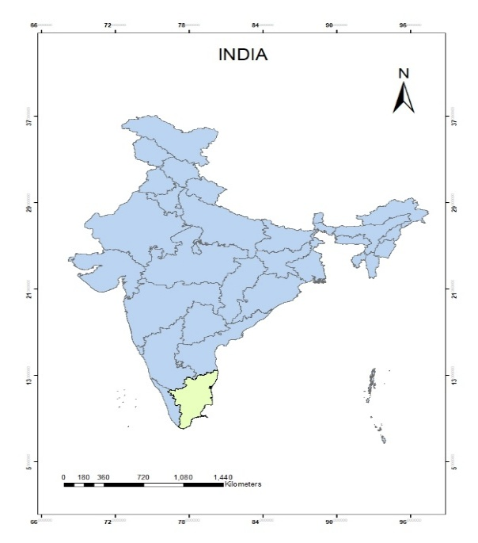 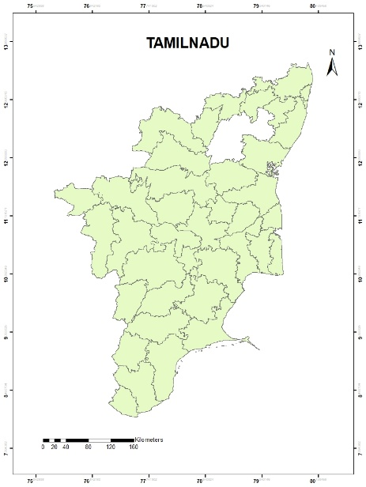

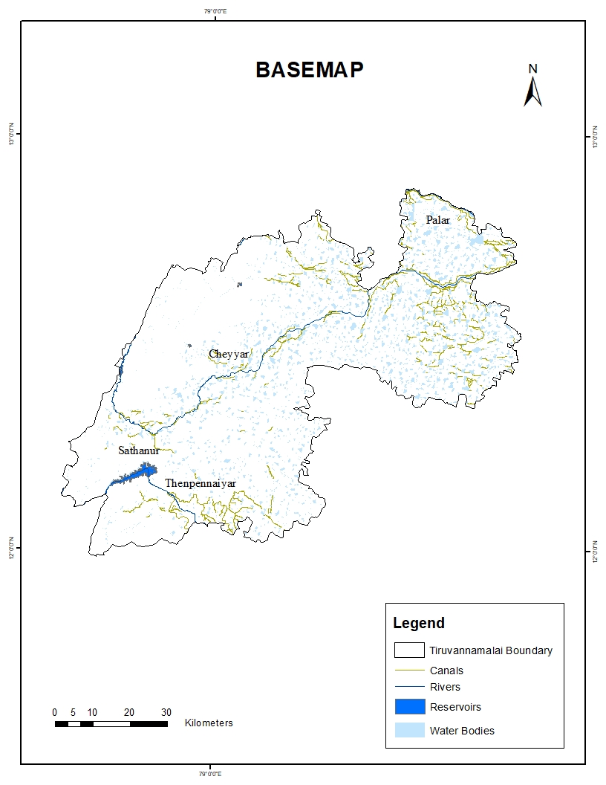

Figure 3.1 Study Area

## 3.3 DESCRIPTION OF THE STUDY AREA

Tiruvannamalai district is one of the administrative districts in the state of Tamil Nadu, India. It is governed by the district administration headquartered in Tiruvannamalai town. Covering an area of approximately 6,188 square kilometers, the district is known for its spiritual significance, historical sites, and natural landscapes. The district is divided into several taluks including Tiruvannamalai, Chengam, Kilpennathur, Polur, Thandrampattu, and others, facilitating efficient local governance and administration.

According to the 2011 Census, the population of the district stands at around 2.46 million, with a mix of urban and rural settlements. Tiruvannamalai lies to the east of the Eastern Ghats, with prominent hills like Arunachala Hill (Annamalai), Parvathamalai, and Jawadhu Hills forming notable landmarks.

The district is drained by several rivers, including the Cheyyar, Palar, Thenpennaiyar, and Kamandala Naganadhi, which play a crucial role in the region’s agriculture and water supply. The Thenpennaiyar sub-catchment covers the southern part of the district. Tiruvannamalai is also prone to natural disasters like floods and landslides, with areas like Puthur, Chekkadi, Rayandapuram, and Annamalaiyar Hills frequently affected. Its unique geography and environmental challenges make it an important area for disaster management and planning in Tamil Nadu.

## 3.4 TOPOGRAPHY OF THE STUDY AREA

Being situated inland in the northern part of Tamil Nadu, Tiruvannamalai is surrounded by undulating terrain with a mix of plains and rocky hills. The region features a moderate topography, gradually sloping outward from the central hill area. The city's average elevation is approximately 200 metres above sea level. The highest elevation is observed around the Annamalai Hills, especially near the Arunachala Hill, which rises to about 814 metres, forming a prominent geographic and spiritual landmark in the region.

## 3.5 GEOLOGY AND DRAINAGE PATTERN

Tiruvannamalai district is mainly underlain by ancient hard rocks such as granite, gneiss, charnockite, and quartzite, which belong to the Archaean group. These rocks form the base of the landscape and give rise to prominent hills like the Arunachala Hill. Due to weathering of these rocks, red sandy and loamy soils are commonly found, especially in the plains. The drainage system of the district is mostly dendritic, influenced by the slope and rock formations. The area falls under the Ponnaiyar river basin, with seasonal rivers like the Cheyyar flowing mainly during the northeast monsoon. These rivers, along with many traditional tanks and ponds, support surface water storage and groundwater recharge. In hilly regions, fractures and joints in the rocks help guide the flow of water. Overall, the rock type and drainage pattern together play an important role in shaping land use, water availability, and the natural environment of Tiruvannamalai.

## 3.6 CONCLUSION

The study area and its description have been explained in this chapter, providing a clear understanding of its geographical and environmental features. This forms the base for the upcoming analysis in the research.

**CHAPTER 4**

# DATA DESCRIPTIOIN AND METHODOLOGY

## 4.1. GENERAL

This chapter outlines the research framework, detailing the materials, methodologies employed in the study.

## 4.2.DATA USED

The data used for assessing flood and landslide susceptibility

are shown in the table 4.1

**Table 4.1** **Data Used**

|  |  |  |
| --- | --- | --- |
| **S.NO** | **DATA** | **SOURCE** |
| 1 | DEM | Bhoonidhi |
| 2 | Sentinel – 1 | GEE |
| 3 | Sentinel – 2 | GEE |
| 4 | SLOPE | CartoDEM - Bhoonidhi |
| 5 | ASPECT | CartoDEM - Bhoonidhi |
| 6 | ELEVATION | CartoDEM - Bhoonidhi |
| 7 | CURVATURE | CartoDEM - Bhoonidhi |
| 8 | STREAM PROXIMITY | CartoDEM - Bhoonidhi |
| 9 | TOPOGRAPIC WETNESS INDEX | CartoDEM - Bhoonidhi |
| 10 | RAINFALL | ARG |
| 11 | ROAD PROXIMITY | TNDRRA |
| 12 | SETTLEMENTS | TNDRRA |
| 13 | SOIL | TNDRRA |
| 14 | GEOLOGY | Bhukosh-Geological Survey of India |
| 15 | GEOMORPHOLOGY | Bhukosh-Geological Survey of India |
| 16 | STREAM POWER INDEX | CartoDEM - Bhoonidhi |
| 17 | LULC | GEE |

## 

## 4.3 DATA DESCRIPTION

### 4.3.1 DEM

A Digital Elevation Model (DEM) is a precise 3D representation of the Earth's surface topography, widely used in Geographic Information Systems (GIS) for generating digital relief maps and analyzing terrain features. This study utilizes CartoDEM, a 30m resolution Digital Elevation Model derived from Bhoonidhi. CartoDEM's high-resolution data enables accurate slope calculations and elevation analysis, forming the foundation for geospatial analysis and informed decision-making.

### 4.3.2 SENTINEL - 1

The Copernicus Open Access Hub, run by the European Space Agency (ESA) as part of the Copernicus Program, provided the Synthetic Aperture Radar (SAR) data from the Sentinel-1 mission. Depending on the geographic location, Sentinel-1's constellation of polar-orbiting satellites (Sentinel-1A and 1B) provide C-band SAR imagery with a spatial resolution of up to 10 meters and a revisit frequency of 6 to 12 days. Continuous surface monitoring of the Earth is made possible by the mission's ability to provide reliable, high-quality radar data regardless of cloud cover or lighting conditions.

Sentinel-1 SAR data is extremely useful in geomorphological studies for monitoring terrain deformation using interferometric SAR (InSAR) techniques and for identifying landform patterns, surface roughness, and structural discontinuities. Its capacity to pierce vegetation and the ability to react to changes in surface moisture improves the detection of erosion-prone regions, slope instabilities, and geomorphic units. This data is essential for assessing the change of the terrain and identifying areas that are vulnerable to landslides and disturbances of the hydrological flow. The Copernicus Open Access Hub, which makes satellite imagery from the Sentinel missions publicly available and free of charge, was used to access the data.

### 4.3.3 SENTINEL – 2

Custom scripts in Google Earth Engine (GEE), a cloud-based geospatial processing platform developed by Google, were used to access and analyze satellite imagery from the Sentinel-2 mission. GEE allows users to perform advanced remote sensing analyses using JavaScript or Python without the need for powerful local hardware. Sentinel-2A and 2B, developed by the European Space Agency (ESA) under the Copernicus Programme, are polar-orbiting satellites that capture high-resolution multi-spectral imagery across 13 spectral bands with spatial resolutions of 10, 20, and 60 meters and a revisit time of approximately five days.

In this study, Sentinel-2 imagery was used to generate a Land Use/Land Cover (LULC) map, essential for understanding landscape dynamics and their influence on flood and landslide impacts. The satellite’s high spatial and temporal resolution enabled accurate classification of urban areas, forests, agriculture, water bodies, and barren lands. Indices such as NDVI and other band combinations were applied to assess vegetation health, surface permeability, and human activity. GEE facilitated rapid access to pre-processed Sentinel-2 datasets, supporting efficient time-series and large-scale analysis.

### 4.3.4 RAINFALL

The rainfall data used in this study was obtained from the Automatic Rain Gauge (ARG) stations. The time period considered is from November 29 to December 3, 2024. ARG are ground-based instruments that automatically record precipitation at regular intervals, providing accurate and high-resolution temporal data. These measurements are essential for analyzing short-term rainfall patterns, which play a significant role in flood and landslide susceptibility assessments.

### 4.3.5 ROAD PROXIMITY

Road network data used in this study was obtained from the Tamil Nadu Disaster Risk Reduction Agency (TNDRRA). TNDRRA is a state-level agency responsible for enhancing disaster resilience through risk assessment, planning, and infrastructure management. The road dataset provides comprehensive geospatial information on the transportation network, which is crucial for identifying vulnerable routes and assessing their susceptibility to flood and landslide hazards.

### 4.3.6 SETTLEMENTS

The Tamil Nadu Disaster Risk Reduction Agency (TNDRRA) provided the settlement data used in this investigation. As part of its mission, TNDRRA promotes the use of community-level data and geospatial technologies to enhance urban planning and disaster preparedness. In order to determine population exposure and assess the possible effects of flood and landslide events on human settlements, the settlement dataset offers a comprehensive spatial distribution of inhabited areas.

### 4.3.7 GEOLOGY

The Geological Survey of India's (GSI) geospatial portal, Bhukosh, provided the geological data used in this investigation. Bhukosh offers extensive spatial datasets and geological maps to assist with planning, research, and hazard assessment in a variety of fields. Lithological and structural data from the geology dataset are essential for assessing regions vulnerable to landslides and other geohazards as well as for comprehending the stability of the terrain.

### 4.3.8 GEOMORPHOLOGY

Bhukosh, a geospatial platform created by the Geological Survey of India (GSI), provided the geomorphological data used in this investigation. Access to comprehensive geomorphological maps produced by field research and satellite image interpretation is made possible by Bhukosh. These datasets allow for a thorough examination of surface processes by classifying landforms according to their origin, structure, and evolution. Since geomorphological features have a direct impact on runoff behavior, slope stability, and the likelihood of flood and landslide events, this information is essential for identifying areas that are vulnerable to natural hazards.

### 4.3.9 SLOPE & ELEVATION

Slope and elevation data derived from CARTO Digital Elevation Models (DEMs) are critical inputs for analyzing terrain characteristics in flood and landslide susceptibility mapping. Slope indicates the steepness of terrain, where steeper slopes are more prone to landslides due to gravitational instability, while flatter areas tend to accumulate runoff, increasing flood risk. Elevation data helps identify low-lying regions that are more vulnerable to water accumulation and flash floods, as well as higher elevation zones that may influence the direction and speed of runoff. Together, these parameters assist in assessing hazard-prone zones and planning risk-reduction strategies.

### 4.3.10 SOIL

The Tamil Nadu Disaster Risk Reduction Agency (TNDRRA) provided the soil data used in this investigation. A variety of thematic layers are available through TNDRRA, including soil maps generated from laboratory analyses and field surveys. These maps offer crucial details about the depth, drainage characteristics, texture, and types of soil in various areas. Understanding soil behavior under various hydrological conditions requires this kind of data, which is especially helpful in locating regions that are vulnerable to erosion, decreased infiltration, and surface instability all of which are important considerations in assessments of flood and landslide vulnerability.

## 4.4 SOFTWARES USED

GIS (Geographic Information System) software is a specialized tool used for capturing, managing, analyzing, and visualizing spatial and geographic data. It enables users to overlay multiple datasets, perform spatial analysis, and generate maps for better decision-making. In this study, GIS software was employed to process Digital Elevation Model (DEM) data, derive layers, and create thematic representations. Its analytical capabilities significantly enhanced the accuracy and clarity of the spatial analysis. The software used for this study includes

1. ArcGIS Desktop

2. ArcGIS PRO

3. GOOGLE EARTH ENGINE

4. GOOGLE EARTH PRO

5. QGIS

6. MS EXCEL

### 4.4.1 ARCGIS DESKTOP

ArcGIS Desktop is powerful GIS software developed by Esri, widely used for viewing, editing, creating, and analyzing geospatial datasets. A key component of this suite is ArcMap 10.8, which was formerly the primary application for geospatial processing within the ArcGIS platform. ArcMap allows users to explore datasets, symbolize geographic features, perform spatial analysis, and create high-quality maps. Its interface consists of two main parts: the Table of Contents, which lists and manages data layers, and the Data Frame, which displays the corresponding map. ArcGIS Desktop supports a variety of spatial data formats and offers advanced geoprocessing tools, including scripting capabilities through ArcPy, making it an essential tool for professionals and researchers working with geographic information across multiple disciplines.

### 4.4.2 ARCGIS PRO

ArcGIS Pro is Esri's next-generation desktop GIS application, designed to provide a more modern, integrated, and powerful environment for spatial data analysis, visualization, and mapping. Unlike its predecessor, ArcMap, ArcGIS Pro supports 64-bit processing and a multi-threaded architecture, enabling faster performance and more efficient handling of large datasets. It features a streamlined user interface with dockable panes, contextual tools, and a ribbon-based layout for improved workflow management. ArcGIS Pro allows users to work with multiple maps and layouts in a single project, supports both 2D and 3D visualization, and offers seamless integration with the ArcGIS Online and Enterprise platforms for sharing and collaboration.

Additionally, it supports Python scripting through ArcPy and Jupyter Notebooks, enhancing its capabilities for automation and advanced geospatial analysis, making it a vital tool for modern GIS professionals and researchers.

### 4.4.3 GOOGLE EARTH ENGINE

Google Earth Engine (GEE) is a powerful cloud-based geospatial analysis platform developed by Google, designed to facilitate large-scale environmental and remote sensing research. It offers access to an extensive, continually updated catalog of satellite imagery and geospatial datasets, including Landsat, MODIS, Sentinel, and global climate and land cover data. GEE enables users to process and analyze petabyte-scale datasets using its integrated JavaScript and Python APIs, all within a high-performance cloud computing environment eliminating the need for advanced local infrastructure. The platform supports time-series analysis, change detection, and spatial modeling, making it especially valuable for applications such as deforestation monitoring, urban expansion, agricultural assessment, and disaster response. Its seamless integration of data, tools, and scalable computation has made Google Earth Engine an indispensable resource for researchers, policymakers, and organizations engaged in geospatial science and sustainable development initiatives.

### 4.4.4 GOOGLE EARTH PRO

Google Earth Pro is a free, advanced version of Google Earth, developed by Google, that allows users to visualize, explore, and analyze geospatial data through an interactive 3D representation of the Earth. It provides high-resolution satellite imagery, aerial photography, terrain data, and geographic layers, enabling users to examine both natural and built environments in detail. Enhanced features include GIS data import (e.g., shapefiles and KML/KMZ files), historical imagery for temporal analysis, and the ability to measure areas and distances accurately. These functionalities make it a valuable tool for urban planning, environmental assessment, educational projects, and site-specific analysis. While it does not offer the large-scale analytical capabilities of platforms like Google Earth Engine or ArcGIS Pro, Google Earth Pro remains an accessible and user-friendly solution for localized spatial visualization and basic geospatial analysis.

### 4.4.5 QGIS

QGIS (Quantum GIS) is a free, open-source Geographic Information System (GIS) application that enables users to visualize, manage, edit, analyze, and map spatial data. Developed and maintained by a global community of contributors, QGIS is widely recognized for its flexibility, extensibility, and compatibility with a broad range of vector, raster, and database formats. It supports complex geospatial analyses through integrated tools and plug-ins, and also provides support for Python scripting via PyQGIS for automation and customization. QGIS features a modern and user-friendly interface, with tools for cartographic layout, geoprocessing, and spatial database management, making it suitable for both beginners and advanced users.

It is commonly used in fields such as environmental science, urban planning, disaster risk management, and public health. As a cost-effective alternative to proprietary GIS software, QGIS continues to gain popularity in academic research, government, and non-profit sectors due to its openness, community-driven development, and adherence to international data standards.

### 4.4.6 MS EXCEL

Microsoft Excel (MS Excel) is a widely used spreadsheet application offering tools for data organization, analysis, and visualization. It supports various functions, including pivot tables, filtering, and chart generation. Excel is valued for handling large datasets, trend analysis, and dynamic presentations. Integration with Visual Basic for Applications (VBA) enables task automation and custom tool development. Though not a dedicated GIS or statistical platform, Excel remains essential in diverse data-driven workflows.

## 4.5 METHODOLOGY

FLOOD AND LANDSLIDE HAZARD VULNERABILE REGIONS

FLOOD SUSCEPTIBILITY MAP

LANDSLIDE SUSCEPTIBILITY MAP

METHODOLOGY

FLOOD INUNDATION AND LANDSLIDE INVENTORY MAP

THEMATIC LAYERS

FREQUENCY RATIO

Figure 4.1 Methodology

SLOPE SOIL

ASPECT GEOLOGY

ELEVATION GEOMORPHOLOGY

CURVATURE LULC

RAINFALL ROAD PROXIMITY

TWI STREAM PROXIMITY

SPI SETTLEMENTS

### 4.5.1 SLOPE MAP

Slope is a fundamental topographic parameter that represents the rate of elevation change over a given horizontal distance, typically expressed in degrees or as a percentage. It is a critical factor in terrain analysis, especially for natural hazard assessments. In this study, slope was derived from the 30-meter resolution CARTO DEM, sourced from the Bhoonidhi. The slope map was generated using the Spatial Analyst tools in ArcGIS, which calculate slope for each cell in the raster based on the elevation values of surrounding cells. Slope plays a vital role in flood and landslide susceptibility mapping. Steep slopes tend to facilitate rapid runoff and are more prone to landslides due to gravitational forces acting on saturated soil. Conversely, gentle slopes may allow water accumulation, increasing flood risk. Therefore, incorporating slope into the analysis helps in delineating high-risk zones and supports informed decision-making for sustainable land use and disaster risk reduction.

### 4.5.2 ASPECT MAP

Aspect refers to the compass direction that a slope faces and is derived from elevation data using terrain analysis tools. It plays a crucial role in determining local microclimatic conditions, including sunlight exposure, wind direction, evaporation rates, and moisture retention all of which can significantly influence vegetation growth, soil stability, and hydrological responses. In this study, aspect was extracted from the 30-meter resolution CARTO DEM, obtained from the Bhoonidhi, using the Spatial Analyst tools in ArcGIS. Aspect is especially relevant in landslide susceptibility mapping, as slopes facing certain directions (e.g., north- or south-facing in specific climates) may receive more rainfall or have different vegetation cover, affecting slope stability.

Additionally, in flood risk analysis, the aspect can indirectly influence runoff patterns and water accumulation. Thus, the aspect is a key terrain parameter that, when integrated with other factors such as slope, soil type, and land use, enhances the accuracy of flood and landslide sustainability assessments.Top of FormBottom of Form

### 4.5.3 ELEVATION MAP

Elevation refers to the vertical distance of a point on the Earth’s surface above a defined datum typically mean sea level and is a fundamental parameter in geospatial analysis of flood and landslide hazards. Digital Elevation Models (DEMs), derived from Bhoonidhi. In flood risk mapping, elevation data enable delineation of inundation extents by identifying low‐lying areas and flow accumulation pathways, while in landslide susceptibility analysis, derived slope steepness and aspect inform the spatial likelihood of slope failure under varying hydrological and geotechnical conditions. By integrating elevation‐derived variables with soil, land cover, and precipitation datasets in a GIS environment, researchers can produce high-resolution, sustainable risk zone maps that support targeted mitigation, land-use planning, and early-warning systems.

### 4.5.4 CURVATURE MAP

Curvature is a topographic parameter that describes the rate of change of slope in a landscape and provides insights into the shape of the terrain surface. Digital Elevation Model (DEM) derived from Bhoonidhi and is typically classified into profile curvature (along the slope) and plan curvature (across the slope). Profile curvature affects the acceleration and deceleration of flow across a surface, influencing erosion and sediment transport, while plan curvature impacts the convergence or divergence of flow, which is critical in water accumulation and slope stability. In this study, curvature was calculated using the 30-meter resolution CARTO DEM obtained from USGS Earth Explorer, processed through the Spatial Analyst tools in ArcGIS. Curvature is particularly valuable in landslide susceptibility analysis, as concave surfaces may promote water accumulation and increase landslide risk, whereas convex areas may enhance runoff. Therefore, curvature is considered an important geomorphological factor in the flood and landslide sustainability mapping process.

### 4.5.5 RAINFALL MAP

Rainfall is a critical climatic parameter that significantly influences both flood generation and landslide occurrence. High-intensity or prolonged rainfall can lead to surface runoff, soil saturation, and increased pore water pressure, all of which contribute to slope instability and flooding in vulnerable regions. In this study, rainfall data were obtained from ARG. The data were integrated into a GIS environment to assess spatial variability and its correlation with topographic and land-use features. Rainfall is considered a key triggering factor in the sustainability mapping of flood and landslide hazards, as it directly affects the hydrological response of the terrain and plays a pivotal role in hazard zoning, risk assessment, and the development of early warning and mitigation strategies.

### 4.5.6 STREAM PROXIMITY MAP

Stream proximity refers to the distance of an area from the nearest stream or drainage line, and it plays a vital role in assessing flood and landslide susceptibility. Areas situated closer to streams are more vulnerable to flooding due to higher chances of water accumulation, overflow, and erosion, particularly during intense rainfall events. In this study, the stream network was extracted from the 30-meter resolution CARTO DEM from Bhoonidhi and using hydrological analysis tools in ArcGIS, such as flow direction, flow accumulation, and stream delineation. To analyze stream proximity, a Multi-Ring Buffer method was applied around the extracted streams at defined intervals, allowing the classification of zones based on their relative distance from drainage channels. This approach enables a more structured and categorical assessment of proximity-related vulnerability, which is especially useful in flood and landslide sustainability mapping. The buffer zones help to delineate high-risk areas near water bodies and inform strategic land-use planning and risk mitigation measures.

### 4.5.7 TWI MAP

Topographic Wetness Index (TWI) is a quantitative measure used in geomorphology and hydrology to estimate the spatial distribution of soil moisture and surface water accumulation based on terrain features. It is calculated using the formula:

TWI = ln (a / tan β) ………………………… (Equation 1)

where *a* represents the upslope contributing area (also known as the specific catchment area), and *β* is the local slope in radians. TWI values indicate the tendency of water to accumulate in a given area — higher values signify zones of potential water saturation, while lower values correspond to well-drained areas.

In the context of flood and landslide susceptibility mapping, TWI is highly valuable. For floods, high TWI values help identify low-lying or concave areas where water is likely to accumulate and cause inundation. For landslides, areas with high TWI indicate higher soil moisture content, which can reduce soil cohesion and increase pore water pressure, thereby elevating the risk of slope failure, especially during heavy rainfall. Therefore, TWI serves as a critical indicator for detecting hydrologically sensitive zones that are more vulnerable to both surface flooding and landslides. In this study, TWI was derived from the Carto dem Digital Elevation Model (DEM) with a spatial resolution of 30 meters, sourced from Bhoonidhi. The TWI layer was generated using hydrological and terrain analysis tools in ArcGIS and integrated with other thematic layers to support comprehensive multi-hazard risk zone mapping.

Top of Form

### 4.5.8 STREAM POWER INDEX MAP

Stream Power Index (SPI) is a topographic index used to estimate the erosive power of flowing water, based on both slope and the concentration of surface runoff. It is calculated using the formula:

SPI = A × tan(β) ………………………… (Equation 2)

where *A* represents the upslope contributing area (flow accumulation), and *β* is the local slope in radians. SPI values reflect the potential energy of water flow at a given location, with higher values indicating areas where water flow is stronger and has a greater capacity to erode the landscape.

In flood and landslide susceptibility mapping, SPI plays a critical role. It is essential because it helps pinpoint areas where the combination of steep slopes and concentrated runoff can lead to severe erosion, channel instability, or slope failure—key factors in both flood and landslide hazards. High SPI values typically occur in zones where both runoff concentration and slope are significant, such as in channels and steep terrains. These areas are more prone to gullying, bank erosion, and slope instability, especially during periods of intense rainfall. For flood mapping, SPI helps identify potential erosion-prone stream banks and flow paths that could influence water accumulation and channel shifts. In landslide analysis, it helps highlight areas where water flow can destabilize slopes by removing support material or increasing pore pressure. In this study, SPI was derived from the 30-meter resolution CARTO DEM, sourced from the Bhoonidhi. The SPI layer was generated using hydrological analysis tools in ArcGIS, including flow accumulation and slope derivation functions. SPI, when integrated with other terrain and climatic factors, enhances the accuracy of multi-hazard sustainability mapping in identifying high-risk zones for targeted disaster management.

### 4.5.9 SOIL MAP

Soil Map is a thematic representation of the spatial distribution of different soil types and their properties across a given area. It provides detailed information on soil characteristics such as texture, structure, permeability, drainage capacity, depth, organic content, and erodibility. In this study, the soil map was obtained from authoritative source TNDRRA. The soil data were integrated into a GIS environment to analyze its influence on hazard susceptibility.

In the context of flood and landslide susceptibility mapping, soil plays a critical role. Soils with low permeability or high clay content tend to retain water, increasing surface runoff and flood risk. Similarly, soils with low cohesion, shallow depth, or high erodibility are more susceptible to landslides, especially when saturated during intense rainfall events. By analyzing the spatial variability in soil properties, the soil map helps identify vulnerable zones where specific soil conditions may exacerbate the effects of hydrometeorological hazards. Therefore, it serves as a key input layer in multi-criteria hazard modeling, supporting sustainable land-use planning and risk mitigation strategies.

## 4.5.10 GEOLOGY MAP

Geology Map is a thematic representation that shows the distribution, nature, and age of different rock types and geological formations at the Earth's surface. It includes information such as rock composition, fault lines, fracture zones, soil-bedrock interface, and structural features like folds and joints. For this study, the geology map was obtained from Bhukosh.

Geological characteristics are crucial in assessing landslide and flood susceptibility. In landslide-prone areas, weak, fractured, or weathered rock formations, particularly sedimentary and metamorphic rocks, increase the risk of slope failure, especially when combined with steep slopes and high rainfall.

Geological faults and joint systems can act as pathways for water infiltration, further destabilizing slopes. In the case of floods, the type of underlying rock can affect permeability and drainage, influencing surface runoff and water retention. Integrating geological data into GIS-based multi-hazard mapping enhances the accuracy of risk zonation and supports informed decision-making for land use planning, infrastructure development, and disaster mitigation strategies.

### 4.5.11 GEOMORPHOLOGY MAP

Geomorphology Map is a thematic representation that illustrates the physical features of the Earth’s surface, such as landforms, terrain types, and the processes that have shaped them over time. These maps categorize regions into geomorphic units like hills, valleys, plateaus, escarpments, floodplains, and coastal zones. For this study, the geomorphology map was obtained from Bhukosh.

In the context of landslide and flood susceptibility mapping, geomorphological characteristics are essential. For landslides, areas with features like steep slopes, escarpments, and dissected hill terrain are inherently more unstable and prone to slope failure. Conversely, floods are more likely in geomorphic units such as valleys, floodplains, and low-lying basins, where water tends to accumulate during heavy rainfall events. Geomorphology maps help in identifying natural drainage patterns, erosion-prone zones, and depositional areas, which are critical for understanding the spatial distribution of natural hazards.

Integrating geomorphology maps into GIS-based multi-hazard assessments allows for more accurate zoning of high-risk areas, supporting sustainable development, infrastructure planning, and targeted disaster mitigation strategies.

### 4.5.12 LULC MAP

Land Use Land Cover (LULC) Map is a thematic map that depicts the physical and human-modified features on the Earth’s surface, including built-up areas, forests, agricultural land, water bodies, wetlands, and barren lands. It reflects both natural and anthropogenic influences on the landscape. In this study, LULC data were sourced from GEE (Google Earth Engine), which provides high-quality satellite-derived land cover classifications updated regularly for India. To classify the LULC categories accurately, training samples were collected for twelve distinct land cover classes: Built-up, Cropland, Forest, Waterbody, Wetland, Barren Land, Grassland, Shrubland, Plantation, Snow/Ice, Sandy Areas, and Fallow Land. These training points were digitized using high-resolution satellite imagery and auxiliary datasets within GEE, ensuring adequate spatial distribution and representativeness across the study area. The collected samples were subsequently used to train a supervised classification algorithm for LULC mapping.

LULC is a key factor in flood and landslide susceptibility mapping. In the case of floods, impervious surfaces such as urban areas and roads reduce infiltration and increase surface runoff, while vegetation cover like forests can reduce runoff and promote infiltration. Similarly, in landslide analysis, land use types such as deforested slopes, agricultural hillsides, and areas undergoing rapid construction are more prone to erosion and instability due to weakened soil cohesion. On the other hand, dense vegetation can act as a stabilizing factor by binding soil and reducing the direct impact of rainfall.

By incorporating LULC maps from Bhuvan into GIS-based hazard assessments, this study can better identify high-risk zones, understand the role of human activity in increasing hazard vulnerability, and support sustainable land-use planning and disaster mitigation efforts.

### 4.5.13 ROAD PROXIMITY MAP

Road Proximity Map is a spatial layer that represents the distance of different areas from the nearest roads. It is created by analyzing road network data to determine how close or far any given location is to a road. In this study, road network data were obtained from TNDRRA. This map is particularly useful in landslide and flood susceptibility mapping. Roads, especially in hilly or poorly drained areas, can disturb the natural slope stability and water flow patterns. In landslide-prone regions, construction and excavation near roads can weaken slopes and trigger slope failures. In flood-prone areas, roads can act as barriers or channels that alter water flow, sometimes causing localized flooding. Proximity to roads helps assess areas where infrastructure development may increase hazard risk and where emergency accessibility is critical during disaster events. Including road proximity in hazard analysis supports more informed planning decisions, helping to minimize risk in vulnerable zones and guide safe infrastructure development.

### 4.5.14 SETTLEMENT MAP

Settlement Map is a spatial representation that shows the distribution and extent of human habitations such as cities, towns, villages, and scattered dwellings. It is used to understand population distribution, urban growth, and infrastructure density across a region. For this study, the settlements data were sourced from the Tamil Nadu Disaster Risk Reduction Agency (TNDRRA), which provides accurate, region-specific data related to disaster risk, including settlement locations and vulnerability profiles. In the context of flood and landslide susceptibility mapping, a settlements map is crucial for assessing exposure and potential impact.

Densely populated or poorly planned settlements located in low-lying floodplains or unstable hilly terrains are highly vulnerable to disasters. By overlaying the settlements map with hazard layers such as slope, rainfall, and soil type, researchers can identify critical zones where human lives, property, and infrastructure are at risk. This helps prioritize areas for mitigation planning, early warning systems, and evacuation routes. Including the settlements map enhances the practical relevance of hazard assessments and supports disaster-resilient urban and rural planning.

### 4.5.15 FLOOD INUNDATION AND LANDSLIDE INVENTORY MAP

Flood Inundation Maps are spatial tools that depict areas prone to flooding due to heavy rainfall, river overflow, or tank breaches, developed by integrating datasets such as rainfall intensity, river discharge, and terrain elevation through hydrological and GIS models. These maps help identify flood-vulnerable regions, especially low-lying zones, poorly drained areas, and locations near water bodies that frequently experience waterlogging and flooding. When overlaid with layers such as land use, population density, and infrastructure, flood inundation maps guide decision-makers in prioritizing flood mitigation efforts, urban planning, and early warning systems.

Complementing flood risk assessments, Landslide Inventory Maps document historical and potential landslide occurrences using satellite imagery, field verification, and slope stability analyses. In hilly and mountainous regions, prolonged rainfall can saturate soils, destabilizing slopes and triggering landslides. The integration of flood inundation maps with landslide inventory data enables comprehensive multi-hazard risk assessments. This combined approach helps identify compound hazard zones, informs slope stabilization measures, regulates construction in risk-prone areas, and supports resilient disaster preparedness plans to safeguard communities and natural environments

### 4.5.16 FLOOD SUSCEPTIBILITY MAP

A Flood Susceptibility Map is a thematic map that identifies areas that are prone to flooding based on various physical and environmental factors. It is generated using geospatial data such as rainfall intensity, slope, elevation, soil type, land use/land cover, drainage density, and historical flood records. These maps help in visualizing the likelihood of flood occurrence across different regions, often categorized into zones like low, moderate, high, and very high susceptibility.

Flood susceptibility maps are essential tools for disaster risk reduction, urban planning, and infrastructure development. They support informed decision-making by helping authorities and communities recognize high-risk areas, plan for emergency response, design flood mitigation structures, and implement effective land-use policies. When combined with settlement and population data, these maps also help in assessing human and economic vulnerability, making them vital for both pre-disaster preparedness and long-term resilience planning.

### 

### 4.5.17 LANDSLIDE SUSCEPTIBILITY MAP

A Landslide Susceptibility Map is a spatial map that highlights areas with varying degrees of potential risk for landslide occurrence based on a combination of natural and human-influenced factors. It is generated using parameters such as slope, aspect, elevation, geology, soil type, land use/land cover, rainfall, drainage pattern, and historical landslide events. These maps classify regions into different susceptibility zones such as low, moderate, high, and very high, helping to visually assess where landslides are more likely to occur.

Landslide susceptibility mapping is a crucial tool in disaster risk management, especially in hilly and mountainous terrains, as it supports safe land-use planning, infrastructure development, and early warning systems. By integrating this map with population and infrastructure data, planners and decision-makers can prioritize high-risk zones for mitigation efforts, community awareness, and sustainable development, reducing the impact of future landslide events.

### 4.5.18 FREQUENCY RATIO

The Frequency Ratio (FR) is a bivariate statistical method commonly used in flood and landslide susceptibility mapping to evaluate the relationship between the spatial distribution of past hazard events and various contributing factors such as slope, geology, land use, and rainfall. It is calculated as the ratio between the area where events (e.g., landslides or floods) occurred within a specific class of a conditioning factor and the total area of that class in the study region.

The FR value greater than 1 indicates a higher likelihood of hazard occurrence in that class, while a value less than 1 suggests lower susceptibility. This method helps identify and rank the influence of different parameters, and when integrated in a GIS environment, it supports the generation of accurate susceptibility maps for effective risk assessment and planning. Compared to other methods, FR offers several advantages. It is a purely data-driven and objective approach, relying on the actual spatial relationship between past hazard occurrences and conditioning factors rather than subjective expert judgment or manually assigned weights. This makes FR more reproducible and less prone to bias. Additionally, it allows for direct quantification of the influence of each factor class based on empirical evidence, enhancing the reliability of susceptibility maps, especially in data-rich environments. Its simplicity, ease of implementation in GIS, and statistical grounding make it a preferred method for standardizing multi-factor hazard analysis.

Number of flood pixels in a class

Total flood pixels

FR =

Total pixels in a class

Total study area pixels

…………… (Equation 3)

Flood pixels in a class = Number of pixels in a specific class where flooding has occurred.

Total flood pixels = Total number of flood-affected pixels in the study area.

Total pixels in a class = Total number of pixels in that specific class.

Total study area pixels = Total number of pixels in the entire study area.

**CHAPTER 5**

# RESULTS AND DISCUSSION

## 5.1. GENERAL

This chapter focuses on the assessment and mapping of flood and landslide susceptibility in the Tiruvannamalai district of Tamil Nadu.

## 5.2 BASEMAP

The basemap of Tiruvannamalai district in figure 5.1 outlines key hydrological features such as rivers, canals, reservoirs, and water bodies, along with the district boundary. Major rivers like Palar, Cheyyar, and Thenpennaiyar are depicted, which are important for understanding water flow and drainage. This map serves as a foundational layer for further spatial analysis and hazard mapping.



Figure 5.1 Basemap

**5.3 SLOPE MAP**

The slope map of Tiruvannamalai in shown figure 5.2, generated using 30-meter resolution CARTO DEM, offers vital insights into flood and landslide susceptibility. The terrain is classified into five slope categories: nearly level (0°–3.68°), gentle (3.69°–10.7°), moderate (10.8°–19.7°), strong (19.8°–28.8°), and steep to very steep (28.9°–85.3°). Nearly level areas are more prone to flooding due to slower runoff and water accumulation, while steep regions face higher landslide risks from gravitational forces on unstable materials. Conversely, steep areas are less flood-prone, and flat areas are less landslide-prone. This classification aids in identifying flood- and landslide-prone zones, serving as a key input for multi-hazard susceptibility mapping and disaster risk reduction planning.

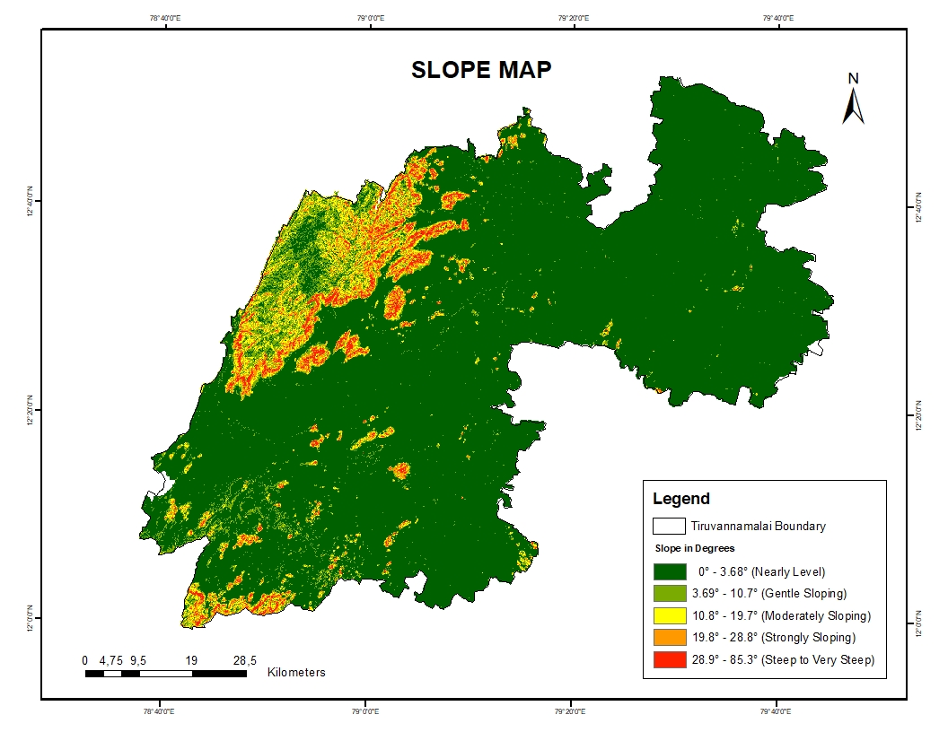

Figure 5.2 Slope Map

## 5.4 ASPECT MAP

The aspect map of Tiruvannamalai shown in figure 5.3, generated from the 30-meter resolution CARTO DEM, classifies the terrain based on slope direction into various aspect classes. Aspect influences factors like sunlight exposure, moisture retention, and vegetation cover, which affect flood and landslide susceptibility. In this study, areas with aspects ranging from S209°55'30''W to N282°07'14''W are identified as more prone to floods and landslides due to their steep slopes and high Stream Power Index (SPI), which increase runoff and erosion potential. In contrast, areas with aspects between N59°52'16''E to S139°08'41''E and N1°00'00''W to N59°52'15''E are less vulnerable because of gentler slopes and lower SPI values. This aspect classification plays an important role in our study by helping pinpoint direction-based risk zones, contributing to more accurate hazard susceptibility mapping and disaster planning.

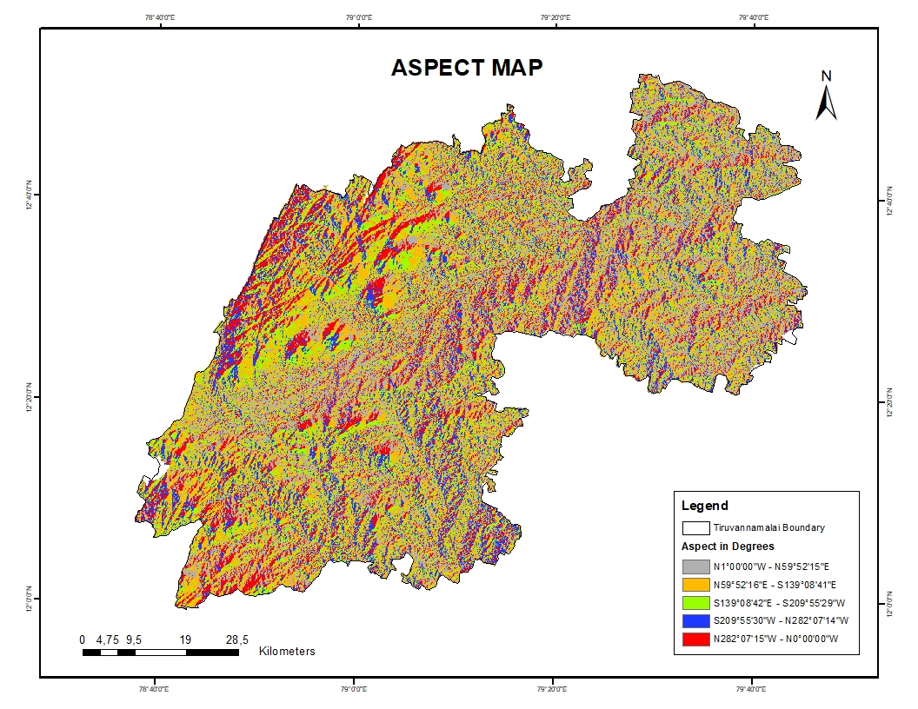

Figure 5.3 Aspect Map

**5.5 ELEVATION MAP**

The elevation map of Tiruvannamalai shown in figure 5.4, generated using CARTO DEM, highlights how elevation and slope influence flood and landslide susceptibility across the district. Areas with lower elevation values (0–53 m and 53–147 m) are more flood-prone due to their low-lying and relatively flat terrain, which allows water to accumulate easily during heavy rainfall. In contrast, higher elevation zones (348–601 m and 601–1031 m) are more landslide-prone due to steeper slopes and rugged terrain that become unstable during intense rainfall or seismic activity. The mid-range elevation class (147–348 m) is relatively less prone to both floods and landslides, representing a transitional zone with moderate slope. This classification supports our study by clearly showing that slope and elevation values directly affect the spatial distribution of these hazards, emphasizing the need to focus risk assessment and mitigation strategies on the respective vulnerable zones.

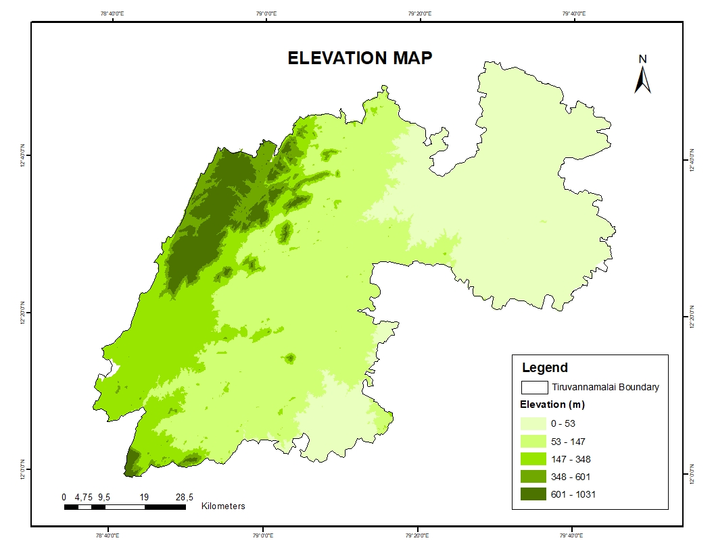

Figure 5.4 Elevation Map

**5.6 CURVATURE MAP**

The curvature map of Tiruvannamalai shown in figure 5.5, classifies the terrain into three curvature categories concave (-210 to -0.6), flat (-0.6 to 0.5), and convex (0.51 to 83)—which help in understanding the surface flow and slope stability patterns critical for flood and landslide analysis. Concave areas are more flood-prone as they tend to accumulate surface runoff, making them susceptible during heavy rainfall events. On the other hand, convex zones are less flood-prone due to their outward-sloping shape that promotes drainage, but they are more landslide-prone because of increased slope steepness and reduced support at the base. Flat areas, although generally stable in terms of landslides, are potential zones for waterlogging and can also contribute to localized flooding. This classification is directly relevant to our study as it highlights how terrain curvature affects hazard susceptibility, supporting the spatial identification of vulnerable zones.

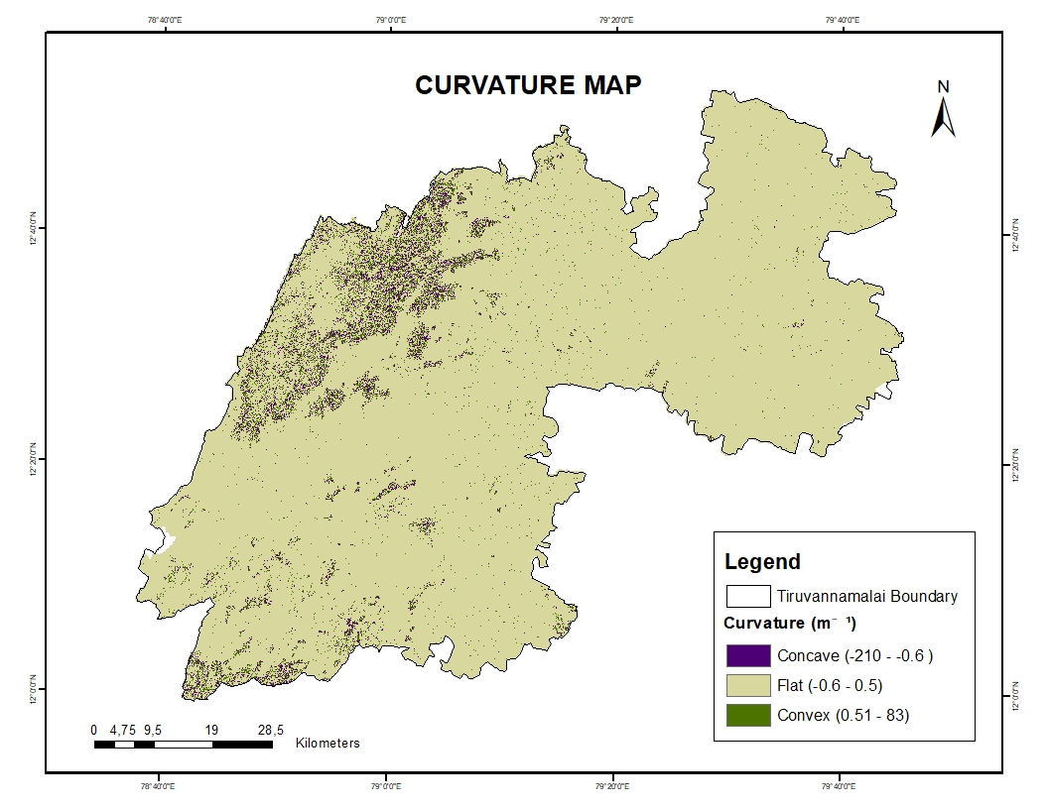

Figure 5.5 Curvature Map

**5.7 RAINFALL MAP**

The rainfall map of Tiruvannamalai shown in figure 5.6, generated using ARG data for the period November 29 to December 3, 2024, shows that areas receiving 251–369 mm and 330–524 mm of rainfall are highly prone to both floods and landslides due to intense runoff and slope saturation. In contrast, regions with 0.02–90.5 mm and 90.6–160 mm of rainfall are less prone to both hazards. This classification aligns with our study by highlighting how rainfall intensity directly influences hazard vulnerability, helping to identify critical risk zones across the district.

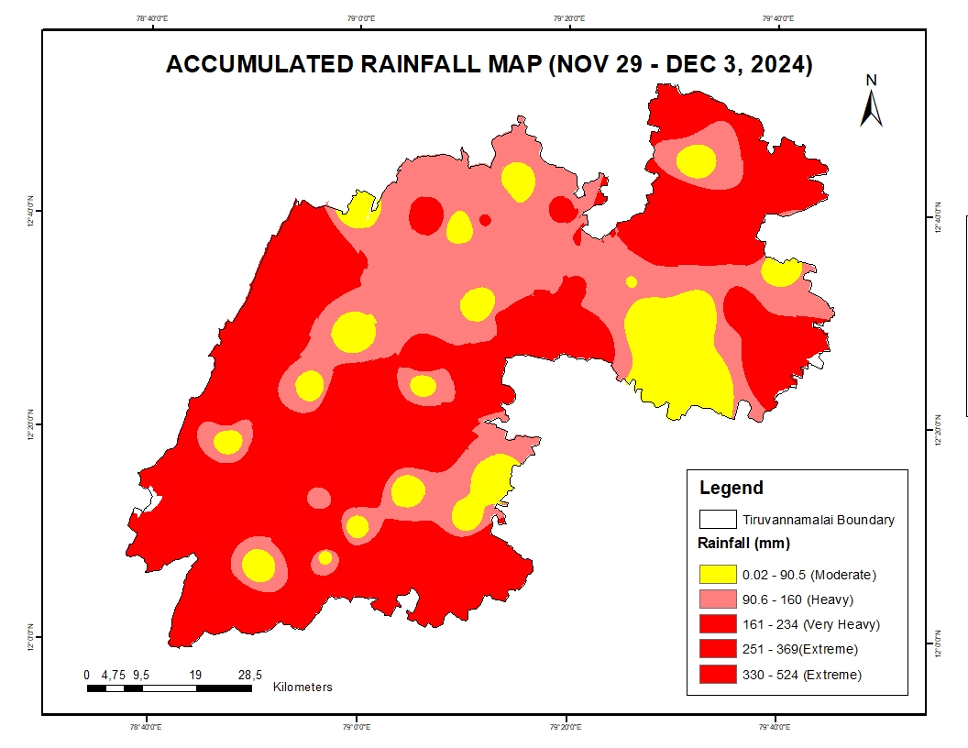

Figure 5.6 Accumulated Rainfall Map

## 5.8 STREAM PROXIMITY MAP

The stream proximity map of Tiruvannamalai shown in figure 5.7, generated using Carto DEM, reveals that areas located within 100 meters of streams are highly susceptible to floods and landslides due to increased runoff accumulation and potential bank erosion. In contrast, regions more than 1000 meters away from streams are less susceptible to these hazards. This classification supports our study by emphasizing the critical role of stream proximity in flood and landslide risk assessment.

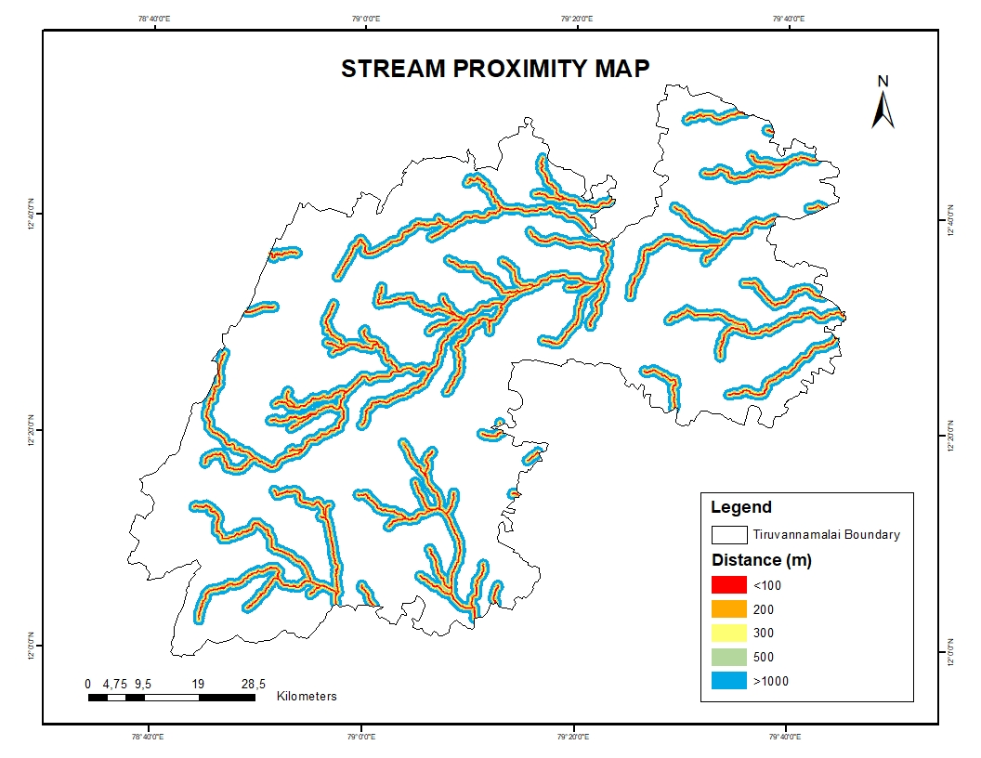

Figure 5.7 Stream Proximity Map

## 5.9 ROAD PROXIMITY MAP

The road proximity map of Tiruvannamalai shown in figure 5.8, developed using TNDRRA data, shows that regions within 0–250 meters of roads are highly prone to floods and landslides due to increased impervious surfaces and disrupted drainage patterns. Conversely, areas lying 1000–4000 meters from roads are less susceptible. This classification reinforces our study’s focus on anthropogenic influence as a critical factor in flood and landslide vulnerability.

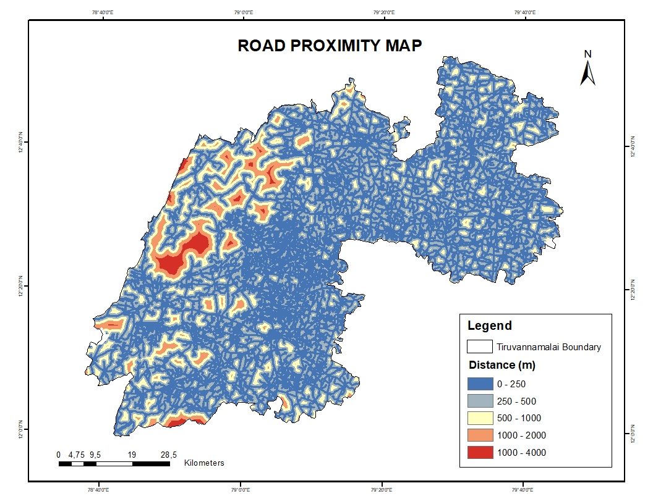

Figure 5.8 Road Proximity Map

## 5.10 SETTLEMENT MAP

The settlements map of Tiruvannamalai created using TNDRRA data shown in figure 5.9, shows that areas within 0–600 meters of settlements are highly susceptible to floods and landslides due to human encroachment and poor drainage infrastructure. In contrast, regions located 2800–5000 meters from settlements are less prone. This classification supports our study’s emphasis on the impact of human settlements on disaster vulnerability.

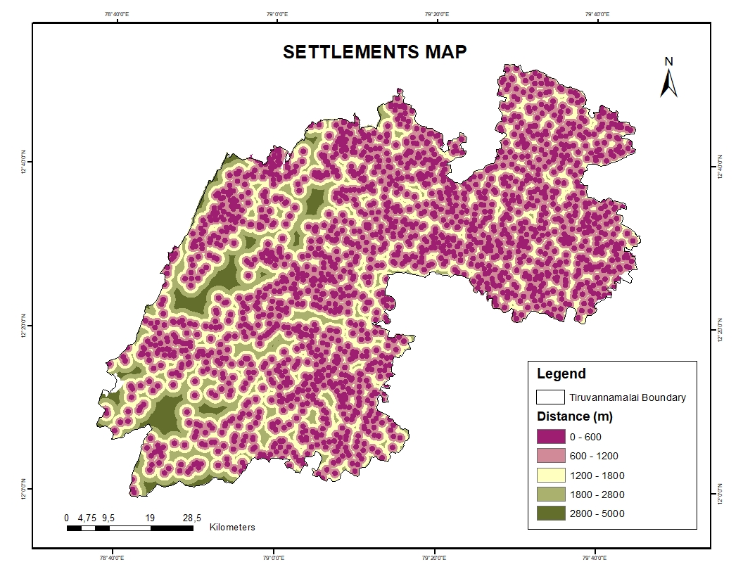

Figure 5.9 Settlements Map

## 

## 5.11 TWI MAP

The Topographic Wetness Index (TWI) map of Tiruvannamalai shown in figure 5.10, generated using CartoDEM, indicates that areas with TWI values ranging from 14.8 to 24.9 are highly flood-prone, due to greater water accumulation in low-lying areas. Moreover, regions with TWI values between 11.5–14.7 and 14.8–24.9 are also more susceptible to landslides, owing to increased soil saturation and slope instability. In contrast, areas with lower TWI values (0.89–6.72 and 6.73–8.98) show lower landslide susceptibility, and values from 0.89–6.72 particularly indicate less flood-prone zones. This classification aligns well with the hydrological and slope dynamics discussed in this study.

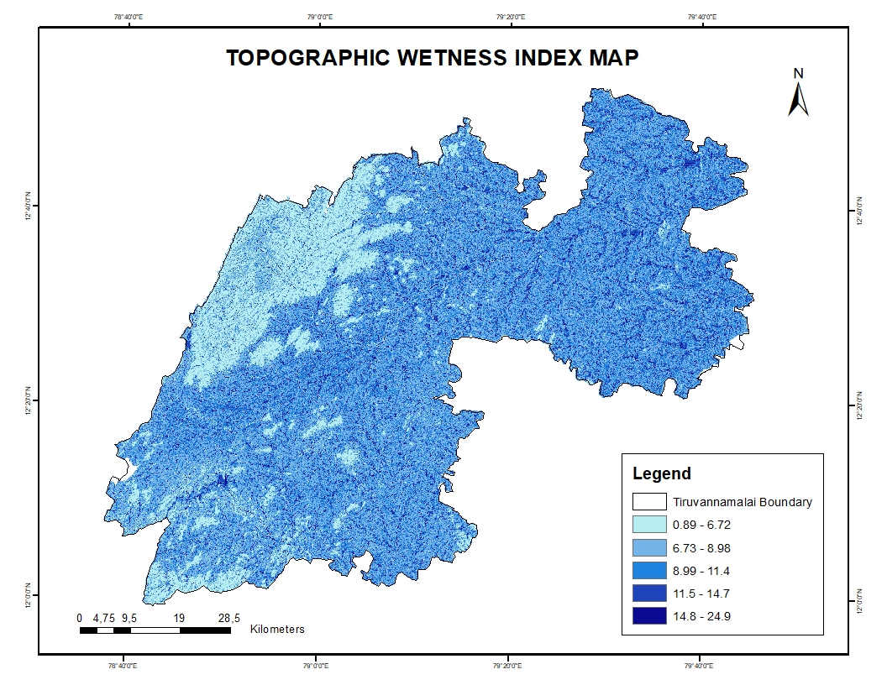

Figure 5.10 Topographic Wetness Index Map

## 5.12 STREAM POWER INDEX

The Stream Power Index (SPI) map of Tiruvannamalai shown in figure 5.11, generated using CartoDEM, indicates that areas with high SPI values (1.6 to 13) are more prone to flooding, as higher stream power correlates with greater erosive force and runoff accumulation. Simultaneously, areas with SPI values ranging from -1.3 to 13 are identified as more susceptible to landslides, due to increased water flow and slope instability. In contrast, regions with very low SPI values (-14 to -8.2) are less prone to both floods and landslides, indicating lower energy and reduced geomorphic activity. These classifications align with the hydrological behavior analyzed in this study and validate the SPI as a crucial indicator in hazard susceptibility mapping.

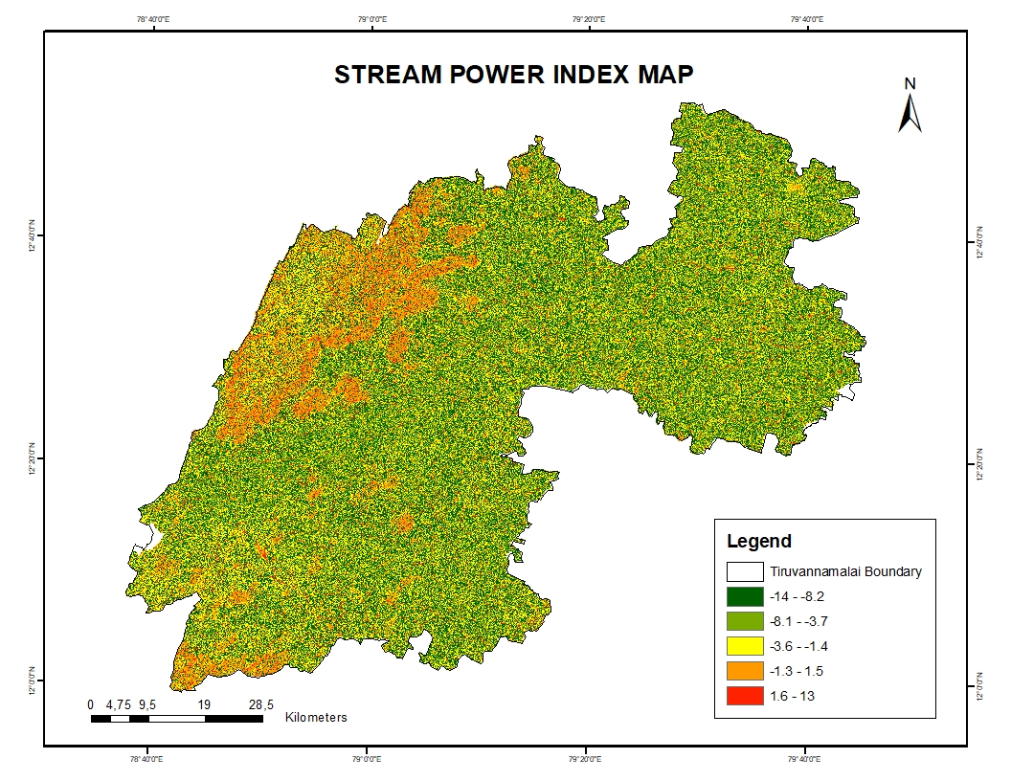

Figure 5.11 Stream Power Index Map

**5.13 GEOLOGY MAP**

The geology map of Tiruvannamalai shown in figure 5.12, generated using Bhukosh and GSI Geology 2M data, highlights the geological classifications across the region. The analysis reveals that areas under Undifferentiated Fluvial sediments are more flood-prone, while regions within the Charnockite Gneissic Complex are relatively less susceptible to flooding. In contrast, zones categorized as Proterozoic Epidote and Migmatite Gneissic Complex show higher landslide susceptibility, whereas Upper Gondwana formations are found to be less prone to landslides. This spatial geological distribution strongly correlates with the observed flood and landslide patterns in our study, indicating a clear link between geology and hazard vulnerability in the Tiruvannamalai region.

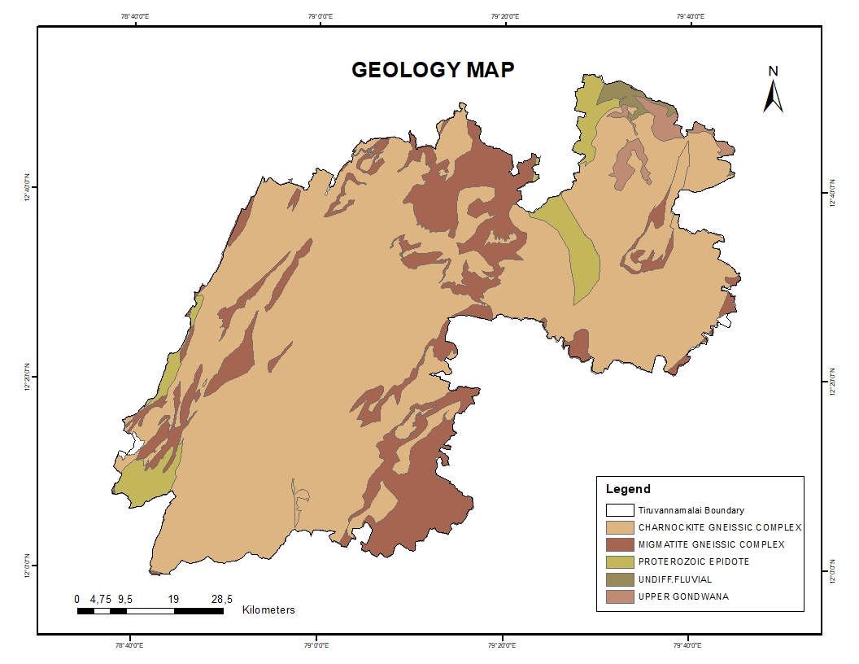

Figure 5.12 Geology Map

**5.14 GEOMORPHOLOGY MAP**

The geomorphology map of Tiruvannamalai, shown in figure 5.13, generated using Bhukosh data, reveals the terrain features influencing flood and landslide susceptibility in the region. Areas classified as Active Flood Plains and Alluvial Fans are highly flood-prone due to their low-lying nature and sediment deposition characteristics. In contrast, Pediments and Plateaus are observed to be less vulnerable to flooding. On the other hand, Gullied Lands and Structural Hills are found to be more susceptible to landslides, while Valleys and Pediplains tend to be less landslide-prone. This geomorphic distribution supports the flood and landslide patterns identified in our SPI-based analysis and provides crucial terrain context to the study’s findings.

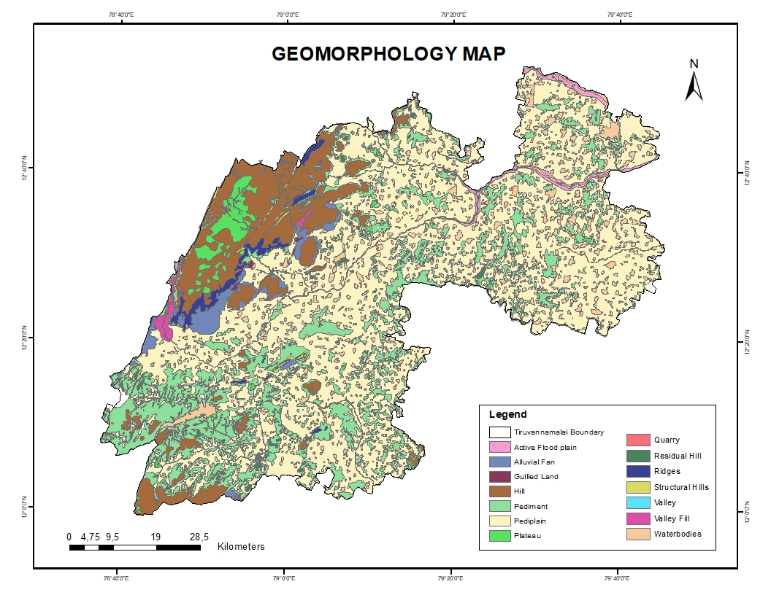

Figure 5.13 Geomorphology Map

## 5.15 SOIL MAP

The soil map of Tiruvannamalai, shown in figure 5.14, generated using TNDRRA data, plays a crucial role in understanding the region’s flood and landslide vulnerability. Areas dominated by Clayey and Fine Silty soils are found to be more flood-prone due to their low permeability and poor drainage. In contrast, regions with Loamy Skeletal and Sandy soils are less susceptible to flooding owing to their better infiltration capacity. For landslides, Loamy Skeletal and Clayey Skeletal soils show higher susceptibility due to their instability on slopes and poor cohesion. Meanwhile, Sandy and Fine Loamy soils are less landslide-prone. These observations are consistent with the flood and landslide patterns observed in the SPI analysis, underscoring the influence of soil type on natural hazard risks in the district.

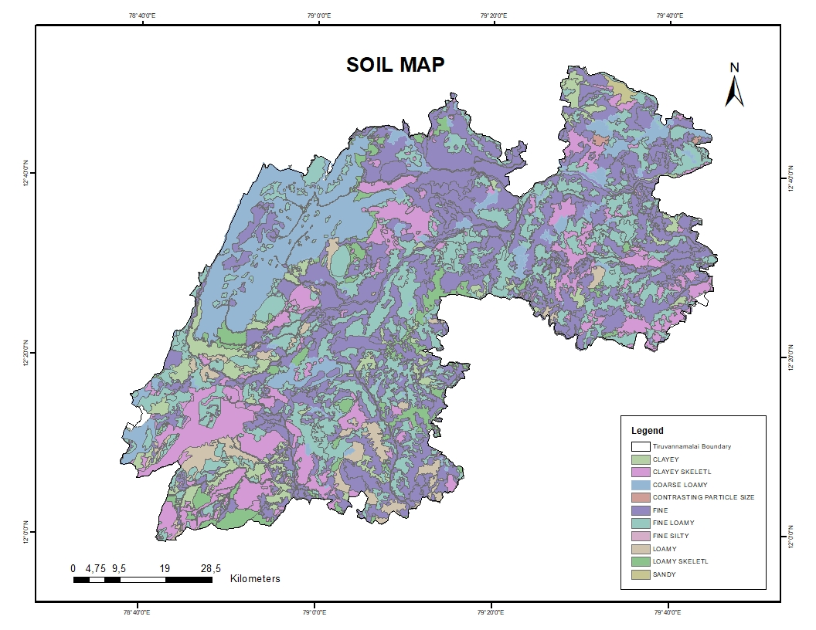

Figure 5.14 Soil Map

## 5.16 LAND USE AND LAND COVER MAP

The study area's Land Use and Land Cover shown in figure 5.15, is divided into 12 categories: Barren Land, Built-up, Crop Land, Deciduous/Semi Evergreen Forest, Dense Evergreen Forest, Fallow Land, Industry, Elevated Area, Reservoir, Sandy Area, Scrub Land, and Waterbody. The classification achieved a Kappa accuracy score of **0.93**, reflecting highly reliable and precise mapping results. FIGURE displays the Land Use and Land Cover map for the study area.

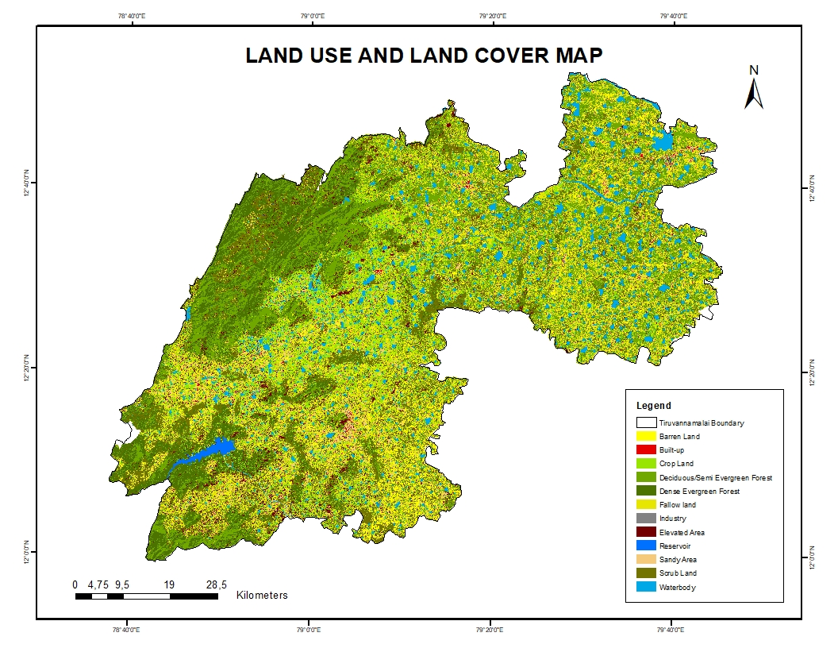

Figure 5.15 LULC Map

## 5.17 FLOOD INUNDATION AND LANDSLIDE INVENTORY MAP

To map flood inundation and landslide inventory of Tiruvannamalai district using Sentinel-1 data in Google Earth Engine (GEE)

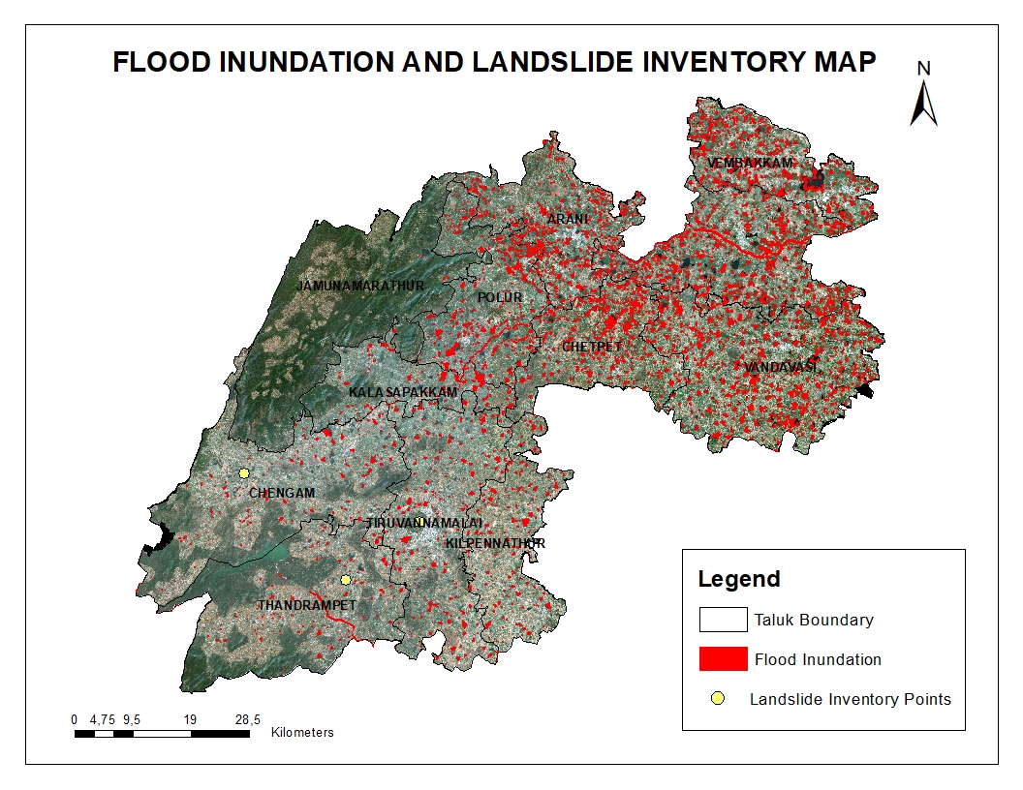

Figure 5.16 Flood Inundation and Landslide Inventory Map

About 15,689.47 hectares were affected by floodwater, as shown on the flood inundation map of Tiruvannamalai district. Mainly in the eastern and southeastern parts of the district, the red-highlighted areas show zones vulnerable to flooding. These places are probably low-lying or close to water bodies, so they may be vulnerable under heavy rain. Disaster preparedness, land use planning, and lowering future flood risks by means of focused mitigation policies all depend on this study as shown in figure 5.16.

Assessed taluk-wise, flood inundation in Tiruvannamalai district showed notable spatial variation. Over all of the taluks, the total flooded area came to be 15,689.47 hectares. Thanks mostly to tank overflows and inadequate drainage, the most badly impacted taluks were Vandavasi (3755.02 ha), Cheyyar (2937.09 ha), and Polur (1448.35 ha). Additional affected areas are Chetpet, Arani, and Tiruvannamalai. Jamunamarathur (11.9 ha) shows minor flooding. Particularly close to Puthur Chekkadi, Rayandapuram, Thiruvathanur, and Kolamajanur, field observations and satellite data confirm that agricultural fields and towns were most severely damaged. Targeted flood control and recovery planning depend on this taluk-wise analysis.

The landslide inventory points, shown in the flood and landslide map of Tiruvannamalai district, highlight key areas vulnerable to slope failure. These points are concentrated in the southwestern and western taluks, including Chengam, Jamunamarathur (Jawadhu Hills), and parts of Tiruvannamalai, especially near the Annamalaiyar Hill. This sacred hill, which is a prominent geomorphological feature, experienced noticeable slope instability during Cyclone Fengal, due to intense and sustained rainfall that triggered minor landslides and soil erosion.

Chengam and Jamunamarathur are geologically sensitive due to their hilly terrain, steep slopes, and deforested patches. Similarly, Annamalaiyar Hill, located at the heart of Tiruvannamalai town, while largely rocky, contains weathered surfaces and loose debris on its flanks, making it susceptible to localized landslides during heavy downpours.

Mapping these points provides essential input for geotechnical studies, slope stabilization, and early warning planning. It also supports integrating multi-hazard data into district-level planning and enhancing community preparedness, especially in environmentally fragile hill zones like the Jawadhu Hills and Annamalaiyar Hill region.

## 5.18 FLOOD SUSCEPTIBILITY MAP

To develop Flood susceptibility map using Frequency Ratio method by integrating Thematic layers.

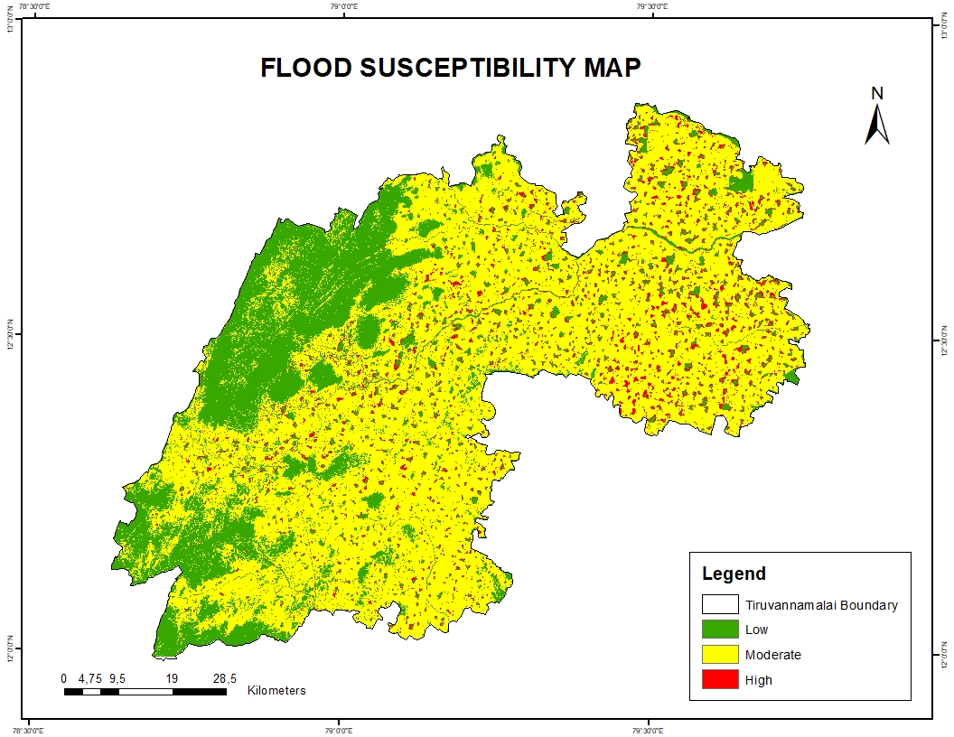

Figure 5.17 Flood Susceptibility Map

The flood susceptibility map divides the study area into three zones based on topographic features, hydrological conditions, and historical flood records: low, moderate, and high flood risk as shown in figure 5.17.

Low flood risk zones are primarily located in the western region. These areas are characterized by higher elevation, steeper slopes, and well-developed natural drainage systems, which facilitate rapid runoff and minimize water accumulation, reducing flood likelihood.

Moderate flood risk zones are scattered throughout the area and typically occur in regions with gentle slopes and moderate drainage capacity. These areas may experience occasional flooding, particularly during periods of intense or prolonged rainfall.

High flood risk zones are concentrated in the central and northeastern parts of the region. These areas are generally low-lying, situated near river networks, and have poor drainage infrastructure. The presence of dense settlements further increases surface runoff, making these zones highly vulnerable to flooding.

This map serves as an essential tool for identifying flood-prone areas, informing land-use planning, and enhancing flood preparedness and disaster management strategies.

The eight highest-ranking parameters based on their normalized PR values are listed in Table 5.1 below.

**Table 5.1****: Flood Frequency Ratio Tabulation**

|  |  |  |
| --- | --- | --- |
| **Parameter** | **Normalized PR** | **Class Description** |
| LULC | 0.245 | Waterbody |
| Rainfall | 0.208 | 330–524 mm (high rainfall) |
| Geomorphology | 0.179 | Active flood plain (possibly flood plain/valley) |
| TWI | 0.141 | 11.5–14.7 (high wetness index) |
| Road Proximity | 0.056 | 0–250 m (near roads) |
| Elevation | 0.050 | Low elevation |
| Stream Proximity | 0.040 | <100 m (closest to streams) |
| Slope | 0.020 | Low slope (0°–3.68°) |

The findings show that the main causes of flooding are low elevation, level terrain, and closeness to roads and streams. These topographical features inherently promote water retention and diminish drainage effectiveness. The importance of precipitation variability in determining flood susceptibility is highlighted by the fact that the highest PR is attributed to LULC, especially waterbody-dominated areas, and that rainfall intensity comes in second.

Strong influences are also shown by the Topographic Wetness Index (TWI) and geomorphological setting, especially in areas on active floodplains or valleys. The ability of a region to store and hold water during rainfall events is reflected in these hydrologically significant parameters.

On the other hand, factors like aspect, curvature, and stream power index (SPI) had little independent influence and were not taken into account in this study's high-impact analysis. The analysis emphasizes how crucial it is to include dynamic variables like rainfall and LULC in early warning and real-time flood monitoring systems. In order to protect vital infrastructure and human life, it also recommends that zoning laws limit development in high flood risk areas, particularly those with FR > 2. In order to lessen vulnerability and increase flood resilience, these high-priority zones should also be the focus of structural mitigation techniques, such as the building of levees, embankments, and better drainage infrastructure.

## 

## 5.19 LANDSLIDE SUSCEPTIBILITY MAP

To develop Landslide susceptibility map via Frequency Ratio approach with thematic layer integration,

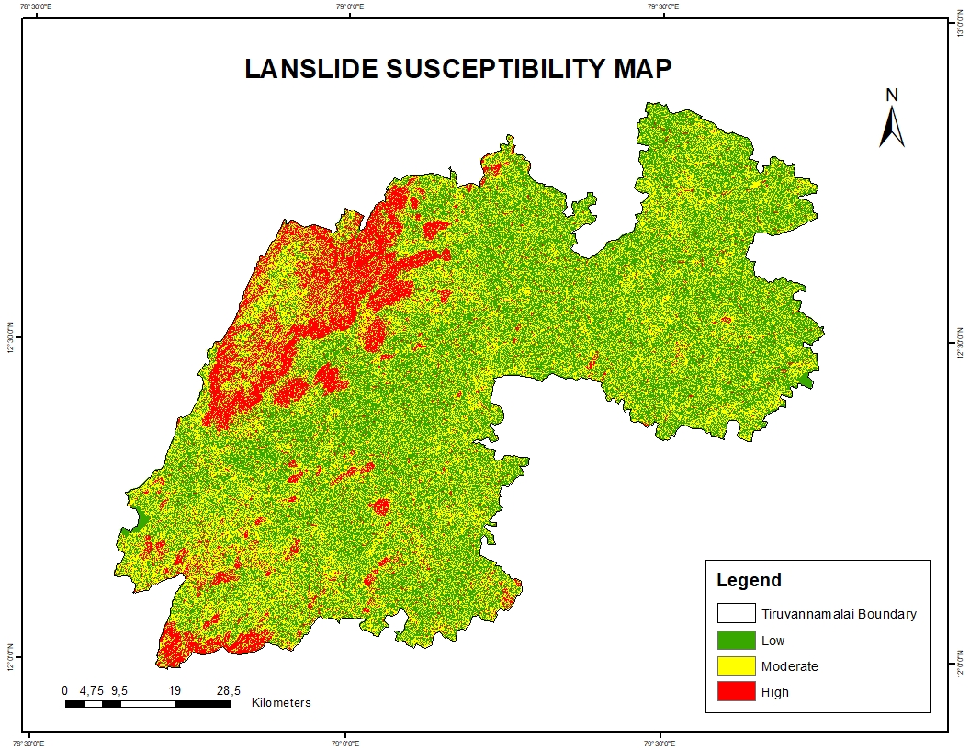

Figure 5.18 Landslide Susceptibility Map

The Landslide Susceptibility Map was developed using the Frequency Ratio (FR) approach, combining various thematic layers such as slope, geology, land use, drainage, and vegetation. This method evaluates the spatial relationship between past landslides and contributing factors to identify areas at risk. Based on this analysis, the study area is classified into three susceptibility zones: low, moderate, and high.

Low susceptibility zones are mainly located in the eastern and northeastern parts of the region. These areas have flat terrain, stable geological conditions, and dense vegetation, which together contribute to natural slope stability and minimal landslide risk.

Moderate susceptibility areas serve as transition zones with variable slope gradients, mixed land use, and moderate vegetation cover. These areas are generally stable but can become prone to landslides under extreme conditions such as heavy rainfall or land disturbance.

High susceptibility zones are concentrated in the western and southwestern parts of the region. These areas feature steep slopes, weak geological structures, and reduced vegetation cover, all of which increase the likelihood of landslides. Such zones require close monitoring and targeted mitigation efforts.

This map acts as a key tool for understanding spatial landslide risks and supports effective decision-making for land-use planning, disaster preparedness, and hazard mitigation strategies.

The six highest-ranking parameters based on their normalised PR values are listed in Table 5.2 below.

**Table 5.2: Landslide Frequency Ratio Tabulation**

|  |  |  |
| --- | --- | --- |
| **Parameter** | **Normalised PR** | **Class Description** |
| Slope | 0.2696 | Steepness is a critical landslide driver |
| Geomorphology | 0.0218 | Structural landforms matter |
| TWI | |  | | --- | | 0.0217 | | Moisture accumulation contributes moderately |
| Curvature | |  | | --- | | 0.0077 | | Highest impact — shape of terrain matters |
| Settlements | 0.0055 | Human development increases instability |
| Elevation | 0.0023 | High terrain more susceptible |

The findings indicate that geomorphological variables are the primary drivers of landslide risk. Notably, curvature, elevation, and slope emerged as the top three contributing parameters. These features collectively influence the terrain's shape and structure, emphasizing their pivotal role in predicting slope failures. Curvature, in particular, showed the highest standalone impact, underscoring the importance of micro-topographic variation in determining landslide-prone zones.

While anthropogenic factors such as settlements showed a measurable impact, their influence was secondary to natural terrain features. Other factors like soil type, land use/land cover (LULC), and stream power index (SPI) demonstrated negligible standalone influence in this particular study, suggesting their contribution may be more context-specific or synergistic with other parameters.These results support a terrain-based approach to zoning and land-use planning, especially in areas identified as high-risk through curvature and elevation analysis. Such insights are vital for policymakers and planners aiming to restrict development in high-PR zones, thereby minimizing human and economic losses due to landslides. give in standard format.

## 

## 5.20 IDENTIFICATION OF VULNERABLE REGIONS

To Identify vulnerable areas to mitigate future impacts and enhance early warning systems and preparedness in the study area.

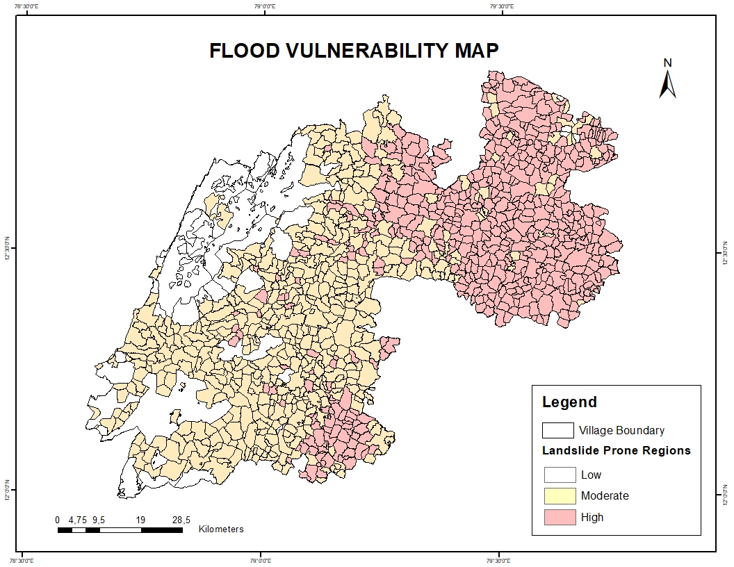

Figure 5.19 Flood Vulnerablility Map

The flood vulnerability map shown in figure 5.19, classifies villages within the study area into three categories based on their exposure and sensitivity to flood hazards: high (pink), moderate (yellow), and low (white) flood-prone zones. This classification considers factors such as proximity to floodplains, elevation, population density, infrastructure quality, and drainage capacity.

* High-vulnerability zones (pink) are primarily located in the eastern and northeastern parts of the region. These areas lie close to river channels and floodplains, making them highly susceptible to inundation during heavy rainfall or river overflow events. Additionally, the higher population density in these zones increases the potential impact of flooding on lives, property, and livelihoods, further elevating their vulnerability.
* Moderate-vulnerability zones (yellow) are distributed across the central and southern regions. These areas may not be directly adjacent to major water bodies but still possess risk factors such as moderate drainage limitations, variable terrain, and a mix of rural and semi-urban land use. While not as exposed as high-risk zones, they remain vulnerable to localized flooding, especially under extreme weather conditions.
* Low-vulnerability zones (white) are mostly found in the western part of the study area. These regions generally benefit from higher elevations, better natural drainage, and lower population density. As a result, the likelihood and impact of flooding in these villages are significantly reduced compared to other parts of the region.

This flood vulnerability map is a vital tool for local disaster risk management and planning. It allows authorities to identify and prioritize the most at-risk communities, design targeted flood mitigation strategies, and allocate resources effectively. By highlighting vulnerable villages, it supports more resilient development and preparedness measures at the grassroots level.

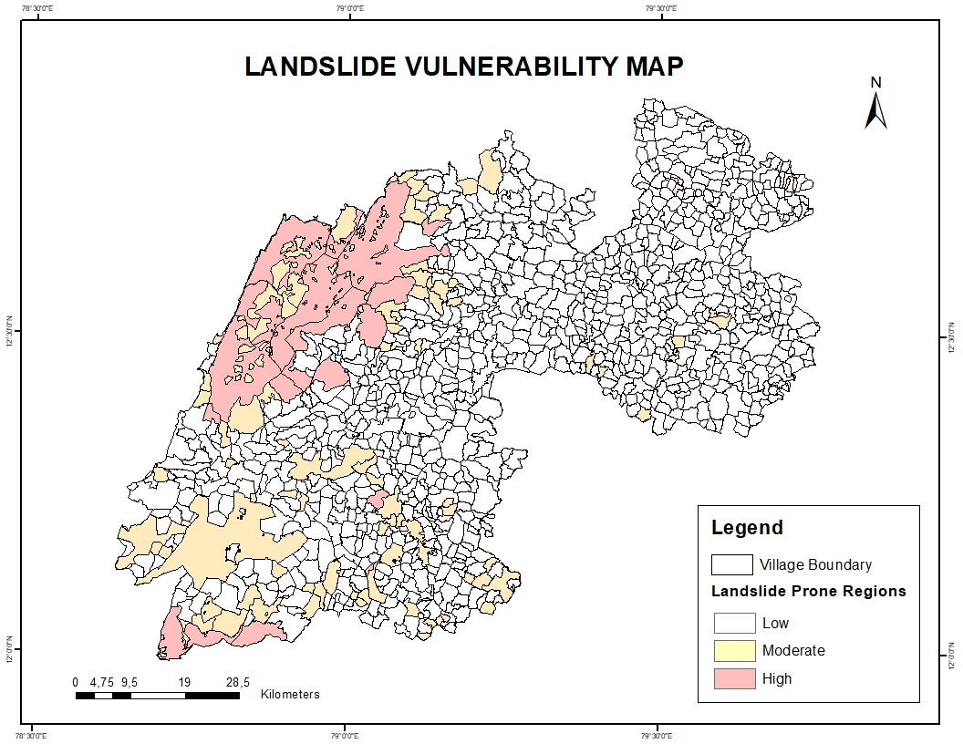

Figure 5.20 Landslide Vulnerability Map

The landslide vulnerability map shown in figure 5.20, categorizes villages into low, moderate, and high vulnerability zones, based on their exposure to landslide hazards. This classification is derived from key contributing factors, including slope gradient, soil type, geological stability, rainfall intensity, vegetation cover, and past landslide occurrences.

* High vulnerability zones (pink) are mainly concentrated in the western and northwestern parts of the study area. These regions are characterized by steep terrain, fragile geological formations, loose or weathered soils, and higher rainfall levels—all of which contribute to unstable slopes and frequent landslide occurrences. Villages in these areas are at greater risk, especially during heavy rain events, and require continuous monitoring and proactive risk mitigation strategies.
* Moderate vulnerability zones (yellow) are predominantly located in the southwestern and central regions. These areas have moderately steep slopes and more stable soil and rock structures compared to high-risk zones. While they may not experience frequent landslides, they remain vulnerable under extreme weather conditions or due to human activities such as deforestation, road construction, or improper land use.
* Low vulnerability zones (white) are found mainly in the eastern parts of the study area, where the terrain is relatively flat, and geological and soil conditions are stable. These areas have minimal exposure to landslide hazards, making them safer for settlement and infrastructure development.

This landslide vulnerability map plays a vital role in disaster preparedness and planning. It helps local authorities and decision-makers identify and prioritize high-risk villages for intervention, implement targeted mitigation measures, and promote safe, sustainable land-use practices. By focusing on the most vulnerable communities, the map supports efforts to reduce landslide impacts and build long-term resilience in hazard-prone areas.

## 5.21 CONCLUSION

The present study employed the Frequency Ratio (FR) method to evaluate flood and landslide susceptibility in Tiruvannamalai by integrating 14 thematic layers encompassing topographic, hydrological, geological, geomorphological, soil, and anthropogenic factors. Flood-prone zones correlate strongly with high Stream Power Index (SPI: 1.6–13) and Topographic Wetness Index (TWI: 14.8–24.9), low elevations (0–147 m), gentle slopes (0°–3.68°), concave curvature (-210 to -0.6), clayey and fine silty soils, and proximity to streams (<100 m), roads (0–250 m), and settlements (0–600 m). Significant rainfall (251–524 mm from Nov 29 to Dec 3, 2024) notably increased flood risk.

Conversely, landslide susceptibility is pronounced in areas with steep slopes (28.9°–85.3°), higher elevations (348–1031 m), convex slope curvature (0.51–83), and specific aspects between S209°55'30''W and N282°07'14''W. These zones are characterized by loamy skeletal and clayey skeletal soils and elevated TWI/SPI values. Geological and geomorphological analysis further distinguishes hazard zones: undifferentiated sediments and active floodplains/alluvial fans are more prone to flooding, while Proterozoic formations, Epidote-Hornblende Gneiss, gullied lands, and structural hills show higher landslide susceptibility. In contrast, Charnockite Gneissic Complex, Upper Gondwana Group, pediplains, valleys, and plateaus exhibit lower vulnerability to both hazards.

This integrated multi-parameter approach underscores the critical interplay of natural and anthropogenic factors in hazard classification, providing a robust basis for disaster preparedness, resilient infrastructure development, and sustainable spatial planning in Tiruvannamalai.

**CHAPTER 6**

# MITIGATION MEASURES

## 6.1 STRUCTURAL MITIGATION MEASURES

Structural mitigation measures involve physical infrastructure designed to manage and reduce the impact of floods and landslides. In flood-prone areas, key interventions include dams, levees, embankments, stormwater drainage systems, and culverts. These structures help control water flow, prevent overflows, and protect settlements and infrastructure from flood damage.

Additional flood-specific structural solutions such as detention basins, floodwalls, and channel improvements enhance the capacity to manage high water volumes. For landslides, retaining walls, check dams, slope stabilization methods, and debris barriers are used to physically restrain soil and prevent debris movement. Proper drainage systems also play a critical role in reducing water pressure within slopes, thereby preventing failure.

## 6.2 NON-STRUCTURAL MITIGATION MEASURES

Non-structural measures focus on reducing vulnerability through planning, education, and policy-based interventions. For floods, these include floodplain zoning, land-use regulations, community-based early warning systems, public awareness programs, and insurance schemes to financially protect affected populations.

In landslide-prone regions, non-structural strategies include hazard mapping, regulations on land use and development, and community education campaigns to promote safer practices. These measures aim to prevent unsafe construction and environmentally harmful activities, ultimately reducing the risk of slope instability and disaster impact**.**

## 6.3 INTEGRATED APPROACH

An integrated approach combines both structural and non-structural measures for a comprehensive disaster risk reduction strategy. Structural methods provide immediate physical protection, while non-structural approaches build long-term community resilience through informed planning and behavior change.

This combined strategy ensures more sustainable and adaptive disaster management. When integrated into local and regional development plans, it enhances preparedness, reduces losses, and supports recovery efforts, contributing to resilient and safer communities.

## 6.4 Inference

Managing flood and landslide risks effectively requires both structural and non-structural measures. Structural solutions offer physical protection, while non-structural approaches improve preparedness and reduce vulnerability. An integrated approach ensures a more sustainable and resilient response to disasters, helping protect lives, property, and support long-term development.

**Top of Form**

**Bottom of Form**

**CHAPTER 7**

# CONCLUSIONS

The present study assessed flood and landslide susceptibility zones in Tiruvannamalai using the Frequency Ratio (FR) method, integrating multiple key influencing parameters such as topography, hydrology, geology, soil types, rainfall patterns, and anthropogenic factors. By combining these thematic layers, the study produced detailed susceptibility maps that delineate areas at varying levels of risk for floods and landslides. These maps serve as vital decision-support tools for proactive urban and regional planning, enabling authorities to prioritize interventions in high-risk zones.

The susceptibility maps facilitate informed decision-making by identifying vulnerable areas, thereby guiding the strategic design and placement of critical infrastructure such as roads, bridges, drainage systems, and housing developments to minimize hazard exposure. Furthermore, they provide a scientific basis for the implementation of early warning systems, allowing timely alerts that can save lives and reduce economic losses during extreme weather events. Emergency response resources can be allocated more efficiently by focusing efforts on the most vulnerable communities, enhancing disaster preparedness and recovery capabilities.

Besides their practical use, these maps help raise awareness among the public about the risks of floods and landslides. They encourage communities to get involved and support efforts to become stronger and better prepared. By sharing information about areas at risk, the study helps local people and leaders improve how they reduce dangers and adapt to changing conditions. Overall, this approach promotes balanced growth while protecting the environment and important social and economic resources in the vulnerable areas of Tiruvannamalai.

# REFERENCE

1. Addis, Abinet. 2023. “GIS – Based Flood Susceptibility Mapping Using Frequency Ratio and Information Value Models in Upper Abay River Basin, Ethiopia.” Natural Hazards Research 3(2): 247–56.
2. Fayaz, Mohsin, Gowhar Meraj, Sheik Abdul Khader, Majid Farooq, Shruti Kanga, Suraj Kumar Singh, Pankaj Kumar, and Netrananda Sahu. 2022.“Management of Landslides in a Rural–Urban Transition Zone Using Machine Learning Algorithms—A Case Study of a National Highway (NH-44), India, in the Rugged Himalayan Terrains.” Land 11(6): 884.
3. Khan, Hawas, Muhammad Shafique, Muhammad A. Khan, Mian A. Bacha, Safeer U. Shah, and Chiara Calligaris. 2019**.** “Landslide Susceptibility Assessment Using Frequency Ratio, a Case Study of Northern Pakistan.” The Egyptian Journal of Remote Sensing and Space Science 22(1): 11–24.
4. Manjari Acharya, Kabi Raj Paudyal, and Rabindra Prasad Dhakal. 2023**.** “Application of Frequency Ratio Method for Landslide Susceptibility Mapping at the Thulo Lumpek Area, Gulmi, Nepal.” ©2023 KarmaQuest International, Canada 7.
5. Saravanan, S, B Istijono, J J Jennifer, D Abijith, and S Sivaranjani. 2021.“Landslide Susceptibility Assessment Using Frequency Ratio Technique – A Case Study of NH67 Road Corridor in the Nilgiris District, Tamilnadu, India.” IOP Conference Series: Earth and Environmental Science 708(1): 012017.
6. Sarkar, Debabrata, and Prolay Mondal. 2020. “Flood Vulnerability Mapping Using Frequency Ratio (FR) Model: A Case Study on Kulik River Basin, Indo-Bangladesh Barind Region.” Applied Water Science 10(1): 17.
7. Soma, A S, U Arsyad, M Nursaputra, A T Lando, S Rahmat, Fidaan Husein Azus, and M D R Ramadhan. 2023**.** “Flood Vulnerability Analysis Using the Frequency Ratio Method with the Watershed Ecosystem in Bulukumba Regency, South Sulawesi Indonesia.” IOP Conference Series: Earth and Environmental Science 1230(1): 012044.
8. Thirumurugan, P., and Muthaia Krishnaveni. 2019**.** “Flood Hazard Mapping Using Geospatial Techniques and Satellite Images—a Case Study of Coastal District of Tamil Nadu.” Environmental Monitoring and Assessment 191(3): 193.
9. Wahba, mohamed, Hassan, Hassan, Elsadek, Wael, Kanae, Shinjiro, and Sharaan, Mahmoud. 2022. “Prediction of Flood Susceptibility Using Frequency Ratio Method: A Case Study of Fifth District, Egypt.” 14 International Conference on Hydro science and Engineering”.
10. Yadav, Manish, Sanjit Kumar Pal, Prasoon Kumar Singh, and Neha Gupta. 2023**.** “Landslide Susceptibility Zonation Mapping Using Frequency Ratio, Information Value Model, and Logistic Regression Model: A Case Study of Kohima District in Nagaland, India.” In Landslides: Detection, Prediction and Monitoring, eds. P. Thambidurai and T. N. Singh. Cham: Springer International Publishing, 333–63.
11. Chellamuthu, S. N., & Ganapathy, P. G. (2024). Quantifying the impact of changing rainfall patterns on landslide frequency and intensity in the Nilgiris District of Western Ghats, India*.* **Discover Sustainability*,* 5*(1).***
12. Singh, N., Gupta, S. K., & Shukla, D. P. (n.d.). Analysis of landslide reactivation using satellite data: A case study of Kotrupi landslide, Mandi, Himachal Pradesh, India*.* School of Engineering, Indian Institute of Technology Mandi.
13. Winter, M. G., Macgregor, C., & Shackman, L. (2000*).* The economic impact of landslides*.* **Quarterly Journal of Engineering Geology and Hydrogeology**, 33(2), 101–110.
14. Mondini, A. C. (2019). Measures of spatial autocorrelation changes in multitemporal SAR images for event landslides detection. **Geoenvironmental Disasters**, 6(1), 18.
15. **Tehrany, M. S., Pradhan, B., & Jebur, M. N. (2014).** Flood susceptibility mapping using a novel ensemble weight-of-evidence and support vector machine models in GIS. Journal of Hydrology, 512, 332–343.
16. **Dou, J., Yunus, A. P., Ebner, P., et al. (2019).** Flood susceptibility mapping using hybrid frequency ratio and logistic regression models in the Nyando River Basin, Kenya. Water, 11(5), 965.
17. **Rahmati, O., Zeinivand, H., & Besharat, M. (2016).** Flood hazard zoning using a combination of frequency ratio and weights-of-evidence models in GIS. International Soil and Water Conservation Research, 4(4), 233–240.
18. **Costache, R., Pham, Q. B., et al. (2020).** Flash-flood susceptibility assessment using weights-of-evidence and decision tree models in a small mountainous catchment of Romania. Journal of Hydrology, 582, 124435.
19. **Khosravi, K., et al. (2018).** Flood susceptibility mapping using machine learning methods: A comparison between random forest, boosted regression tree, and multivariate adaptive regression spline. Journal of Hydrology, 562, 435–449.